**APPENDIX 1**

**Contrasting assignment of migratory organisms to geographic origins using long-term versus year-specific precipitation isotope maps**

Vander Zanden, H.B., Wunder, M.B., Hobson, K.A., Van Wilgenburg, S.L., Wassenaar, L.I., Welker, J.M., and Bowen, G.J.

**Materials and methods**

*Case studies*

Some sites from the original monarch butterfly and reed warbler datasets were not included in this study. The original monarch dataset included individuals from 6 sites in Canada, but we restricted the dataset to the sites within the continental United States in order to use the high spatial resolution PRISIM temperature data (PRISM Climate Group 2010) as a covariate in creating the isoscapes, as these data were only available for the contiguous United States. One of the sites in the original warbler dataset was not included in the analyses and was considered an outlier (Lake Constance, Germany) because these birds nested along water that was exceptionally depleted in 2H from Alpine snowmelt rather than rainfall (Procházka *et al.* 2013).

*Isoscape mapping*

Long-term mean annual precipitation isoscapes have been widely used as a result of two limitations in predicting *δ*2Hp values for more specific short-term time frames. First, *δ*2Hp values in the primary data sources such as GNIP are discontinuous both in space and time, as *δ*2Hp data are not available for all years and months at all sampling localities (Bowen 2010). Second, the computational effort associated with producing, distributing, and updating time-specific isoscapes was previously prohibitive, but new tools such as the IsoMAP online workspace (Bowen *et al.* 2012) allow users to create customized isoscapes to predict the stable isotope ratio distributions of precipitation for specific regions and time periods of interest (Bowen *et al.* 2014).

We used IsoMAP to develop *δ*2Hp isoscapes for each time period relevant to our datasets. The following model covariates were included in the regression models: elevation, latitude, longitude, monthly amount of precipitation (measured at each station), and monthly minimum temperature (from PRISM Climate Group) (U.S. National Geophysical Data Center 1998; Welker 2000; Mitchell & Jones 2005; PRISM Climate Group 2010; IAEA/WMO 2011). The isotopic composition of precipitation generally covaries with latitude and altitude, primarily due to temperature-driven distillation of the heavy water isotopes from air masses as they move to cooler, higher latitudes, as well as the total amount of precipitation (Dansgaard 1964; Rozanski Araguás-Araguás & Gonfiantini 1993; Bowen & Wilkinson 2002). For this reason, these environmental variables were included in addition to longitude.

In the process of developing precipitation models in IsoMAP, a standard regression model is created that incorporates the independent variables that are selected by the user to predict *δ*2Hp values across the landscape. When significant spatial autocorrelation in the regression model residuals is detected, IsoMAP generates a geostatistical model (in addition to the standard regression model) to incorporate spatial correlation within the datasets. In the long-term models, both a standard multiple regression model as well as a geostatistical model were generated. Significant spatial autocorrelation was not detected in the shorter time periods, thus geostatistical models were not produced. For this reason, only the isoscapes generated from the regression models were used for both the short- and long-term time frames. The *δ*2Hp isoscapes created for this study are depicted in Fig. S1 and are also available on www.isomap.org (see Table 1).

*Mean rescaling functions*

For each of the 1000 simulated regressions, *δ*2Htissue and *δ*2Hp values were randomly drawn from a normal distribution using the site isotopic mean and SD values. The number of data points that were generated for each site corresponded to the number of monarch butterflies (n = 1-6) or reed warblers (n = 3-20) sampled at that site to maintain the total number of individual samples constant in each regression. The mean and SD *δ*2Hp values for the warbler sites were determined for the year corresponding to the date on which birds were sampled at that site. The mean regression parameters from the 1000 regressions were used to generate a linear equation to transform the *δ*2Hp isoscape to one reflecting the animal *δ*2Htissue values. Therefore, a single rescaling function was generated for each species such that *δ*2Hp values from 1996 were included in the monarch butterfly equation while *δ*2Hp values from all three years between 2004-2006 were included in the reed warbler equation (Fig. S2). These equations were used to generate a single *δ*2Htissue isoscape for the monarch butterflies for the year 1996, while three *δ*2Htissue isoscapes were generated for the reed warblers for the years 2004, 2005, and 2006 (Fig. S3).

*Variance estimation*

The rescaling variance (*2rescale*) reflected the uncertainty in the model used to rescale *δ*2Hp to *δ*2Htissue values, whereas the precipitation variance (*2precip*) was derived from the uncertainty in isoscape model parameters across the landscape where precipitation measurements were not made. The individual variance component (*2individ*) reflected the mean variance among individuals at a single site and accounted for analytical error as well behavioral and physiological differences among individuals in the assimilation of environmental H and allocation to growth. Estimates of the standard deviation in the *δ*2Htissue values for monarchs raised in captivity on the same diet ranged from 4-11 ‰ depending on the treatment (Hobson, Wassenaar & Taylor 1999), whereas the value of *individ* calculated for the monarchs in this study was lower (3.8 ‰). The variance component associated with rescaling may be a slight overestimate, as it also reflects some of the variance among individuals and in the precipitation, though it was generally the smallest of the three (Fig. S4 and S5). Although we did not explore the effects of variance directly here, it is generally the case that the magnitude of the variance affects the precision of geographic assignments (Wunder 2010), and the among-individual variance at a given site is likely to be the largest source of variation (Wunder & Norris 2008; Wunder *et al.* 2012).

*Geographic assignment methods*

Bayes rule was used to invert the conditional probability of the measured *δ*2Htissue values, given the sampling location:

$P\left(A_{i} | B\right)=\frac{P\left(B | A_{i}\right)P\left(A_{i}\right)}{Σ_{i}P\left(B∨A_{i}\right)P\left(A_{i}\right)}$ (eqn S1)

where *P*(*Ai*|*B*) is the posterior probability distribution of a sample originating in geographic location *i,* given the observed *δ*2Htissue value. *P*(*B*|*Ai*) is the likelihood probability distribution of obtaining the observed *δ*2Htissue value at geographic location *i*, and (*Ai*) is the prior probability distribution of a sample originating in geographic location *i*. The denominator is a constant, and thus the probability density is proportional to the numerator. A uniform prior probability equal to 1 was used, such that all locations within the precipitation isoscapes were equally likely. Equation S1 reduces to the likelihood term:

$P\left(A_{i} | B\right)∝L\left(y | μ_{i},σ_{i}^{2}\right)=\frac{1}{\sqrt{2πσ_{i}^{2}}}e^{\frac{{−\left(y−μ_{i}\right)}^{2}}{2σ_{i}^{2}}}$ (eqn S2)

where *L* is the likelihood of the **2H value *y* at geographic location *i* given modeled mean (*i*) and variance (*i2*) values for tissues formed at that location. Values of *i* represent the *δ*2Htissue values in the relevant isoscape, and *i* represents the pooled variance defined in the main text.

*Evaluation of assignment efficacy*

The similarity index used in this study was adopted from the Expected fraction of Shared Presences (ESP) metric proposed by Godsoe (2014), which was derived from Sørensen’s similarity index and was computed as:

$\begin{aligned}P \\ \sum_{j}{\left( | 1j{+P}_{2j}\right)} \\ ESP=\frac{2\sum_{j}{P_{1j}P_{2j}}}{}\end{aligned}$ (eqn S3)

where the posterior density surface was recoded to a binary surface at a given threshold, such that P*1j* is the number of cells that had a posterior probability greater than the threshold for the short- term assignment; P*2j* is the number of cells that had a posterior probability greater than the threshold for the long-term assignment. Therefore, the numerator represents the number of cells meeting the criterion for both assignment methods and the denominator indicates the total number of cells meeting the criterion across both assignments at a given relative probability value. The ESP was calculated over the range of relative probability intervals (between 0.01 and 0.99) for assignments made with short- and long-term isoscapes for each individual.

**Table S1.** Monarch butterfly sampling site latitude, longitude, elevation, as well as mean, range, SD of *δ*2Htissue values and number of individuals sampled (divided by calibration and validation sites). Original data from Hobson, Wassenaar & Taylor (1999).

|  |  |  |  |  |  |  |  |  |
| --- | --- | --- | --- | --- | --- | --- | --- | --- |
| **Site ID** | **Latitude** | **Longitude** | **Elevation (m)** | **Mean**  ***δ*2H (‰)** | **Range *δ*2H (‰)** | **SD** | **n** | **Location** |
| All sites |  |  |  | -101.3 | 53.9 | 2.1 | 97 |  |
| *Calibration*  C1 | 48.21 | -101.55 | 608 | -113.8 | 5.3 | 2.9 | 3 | Des Lacs, ND |
| C2 | 45.83 | -96.85 | 332 | -105 | 0 |  | 1 | Fargo, ND |
| C3 | 44.44 | -69.43 | 130 | -117 | 7.8 | 3.5 | 5 | Madison, ME |
| C4 | 43.01 | -91.24 | 310 | -101.1 | 1.3 | 0.9 | 2 | Monona, IA |
| C5 | 42.55 | -73.48 | 335 | -111.8 | 6.2 | 3.4 | 3 | Round Lake, NY |
| C6 | 40.95 | -76.88 | 152 | -101.2 | 6.3 | 3.2 | 3 | Lewisburg, PA |
| C7 | 40.78 | -96.71 | 363 | -96.6 | 8.4 | 4.7 | 3 | Lincoln, NE |
| C8 | 39.58 | -86.06 | 254 | -107.6 | 5.7 | 2.9 | 3 | Carmel, IN |
| C9 | 39.01 | -99.51 | 685 | -104.7 | 17.2 | 6.5 | 5 | Wakeeney, KS |
| C10 | 37.4 | -92.4 | 344 | -102 | 6.8 | 2.9 | 4 | Lebanon, MO |
| C11 | 36.46 | -97.35 | 297 | -90.8 | 0 |  | 1 | Red Rock, OK |
| C12 | 35.8 | -78.7 | 125 | -96.7 | 6 | 2 | 6 | Raleigh, NC |
| C13 | 34.83 | -82.4 | 285 | -94.3 | 8.3 | 4.7 | 3 | Greenville, SC |
| C14 | 33.56 | -96.95 | 209 | -95.6 | 15.2 | 6.4 | 5 | Cedar Hill, TX |
| C15 | 33.37 | -91.48 | 37 | -85 | 5.9 | 3.1 | 3 | Monticello, AR |
| C16 | 25.88 | -80.6 | 2 | -91.6 | 1.5 | 0.8 | 3 | Miami, FL |
| *Validation*  V1 | 44.21 | -100.22 | 548 | -113.4 | 12.3 | 5.1 | 5 | Fort Pierre, SD |
| V2 | 44.2 | -69.4 | 60 | -105.6 | 6.4 | 3.5 | 3 | Jefferson, ME |
| V3 | 42.58 | -85.6 | 242 | -100.4 | 23.3 | 8.6 | 6 | Grand Rapids, MI |
| V4 | 42.4 | -76.5 | 346 | -120.7 | 16.2 | 6.2 | 6 | Ithaca, NY |
| V5 | 40 | -76.3 | 97 | -120.5 | 2.4 | 0.8 | 6 | Lancaster, PA |
| V6 | 36.9 | -80 | 373 | -97.6 | 4.2 | 3 | 2 | Ferrum, VA |
| V7 | 35.93 | -86.01 | 313 | -86.2 | 16.5 | 5.8 | 6 | Madison, TN |
| V8 | 35.27 | -97.29 | 338 | -95.3 | 5.6 | 3 | 4 | Oklahoma City, OK |
| V9 | 29.58 | -90.09 | 0 | -96.4 | 14.4 | 7.9 | 3 | Metairie, LA |
| V10 | 29.14 | -98.37 | 168 | -82 | 7.1 | 3.6 | 3 | San Antonio, TX |

**Table S2.** Reed warbler sampling site latitude, longitude, elevation, as well as mean, range, SD of *δ*2Htissue values and number of individuals sampled (divided by calibration and validation sites). Original data from Procházka et al. (2013).

|  |  |  |  |  |  |  |  |  |
| --- | --- | --- | --- | --- | --- | --- | --- | --- |
| **Site ID** | **Latitude** | **Longitude** | **Elevation (m)** | **Mean**  ***δ*2H (‰)** | **Range *δ*2H (‰)** | **SD** | **n** | **Location** |
| All sites |  |  |  | -119 | 112.7 | 2.4 | 214 |  |
| *Calibration*  C1 | 60.4 | 22.3 | 17 | -98.9 | 21.9 | 5.8 | 15 | Rauvola, Finland |
| C2 | 59.42 | 10.82 | 25 | -95.2 | 9.5 | 2.9 | 10 | Blixoya, Norway |
| C3 | 54.38 | 19.42 | 2 | -95.9 | 13.2 | 4.5 | 8 | Sikierki, Poland |
| C4 | 54.23 | 10.27 | 31 | -83.8 | 18.3 | 5.7 | 9 | Scharsee, Germany |
| C5 | 52.52 | 5.48 | 0 | -87.2 | 18.3 | 7.0 | 10 | Almere, Netherlands |
| C6 | 49.97 | 23.47 | 249 | -70.5 | 25.9 | 6.4 | 8 | Cholgyni, Ukraine |
| C7 | 48.9 | 17.03 | 167 | -78.1 | 7.2 | 9.6 | 3 | Luzice, Czech Republic |
| C8 | 48.53 | 17.85 | 146 | -79 | 29.8 | 9.1 | 7 | Trnava, Slovakia |
| C9 | 48 | -4.5 | 39 | -79.1 | 16.8 | 5.5 | 10 | Trunvel, France |
| C10 | 45.57 | 15.63 | 110 | -52.3 | 24.4 | 8.5 | 8 | Draganic, Croatia |
| C11 | 43.88 | 15.55 | 3 | -39 | 23.8 | 8.1 | 8 | Vransko Lake, Croatia |
| C12 | 38.08 | -8.78 | 1 | -51.2 | 12.9 | 3.8 | 8 | Santo Andre, Portugal |
| C13 | 31.82 | 36.8 | 508 | -115.6 | 31 | 6.8 | 20 | Azraq, Jordan |
| *Validation*  V1 | 59.9 | 29.85 | 2 | -113.1 | 23.8 | 9.0 | 8 | St. Petersburg, Russia |
| V2 | 55.35 | 21.22 | 1 | -89.6 | 4.7 | 2.0 | 5 | Ventes Ragas, Lithuania |
| V3 | 52.3 | 24.35 | 152 | -83.3 | 0 |  | 1 | Bereza, Belarus |
| V4 | 51.92 | -3.27 | 155 | -101.1 | 13.1 | 4.9 | 7 | Llangorse, UK |
| V5 | 49.88 | 16.28 | 374 | -91.4 | 10.8 | 3.4 | 8 | Osik, Czech Republic |
| V6 | 49.65 | 10.83 | 290 | -91.4 | 14.3 | 6.8 | 10 | Poppenwind, Germany |
| V7 | 46.78 | 19.35 | 95 | -57.2 | 21.6 | 6.8 | 10 | Kolon Lake, Hungary |
| V8 | 43.25 | -8.58 | 75 | -74.6 | 10.4 | 4.3 | 8 | Barranan, Spain |
| V9 | 42.92 | 22.92 | 701 | -55.4 | 21.9 | 10.4 | 4 | Dragoman, Bulgaria |
| V10 | 42.07 | -4.75 | 741 | -46.7 | 37.1 | 10.5 | 8 | La Nava, Spain |
| V11 | 41.15 | 14.3 | 25 | -28.7 | 11.8 | 3.9 | 7 | Lagnone, Italy |
| V12 | 35.95 | 14.38 | 3 | -25.3 | 21.9 | 7.3 | 8 | Is-Simar, Malta |
| V13 | 35.63 | -5.25 | 25 | -119 | 11.4 | 3.9 | 6 | Smir, Morocco |

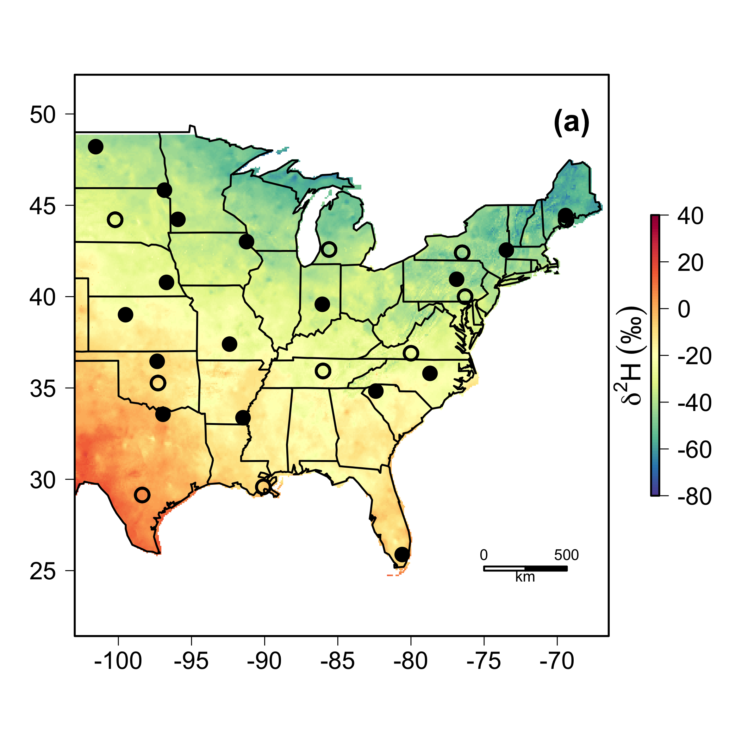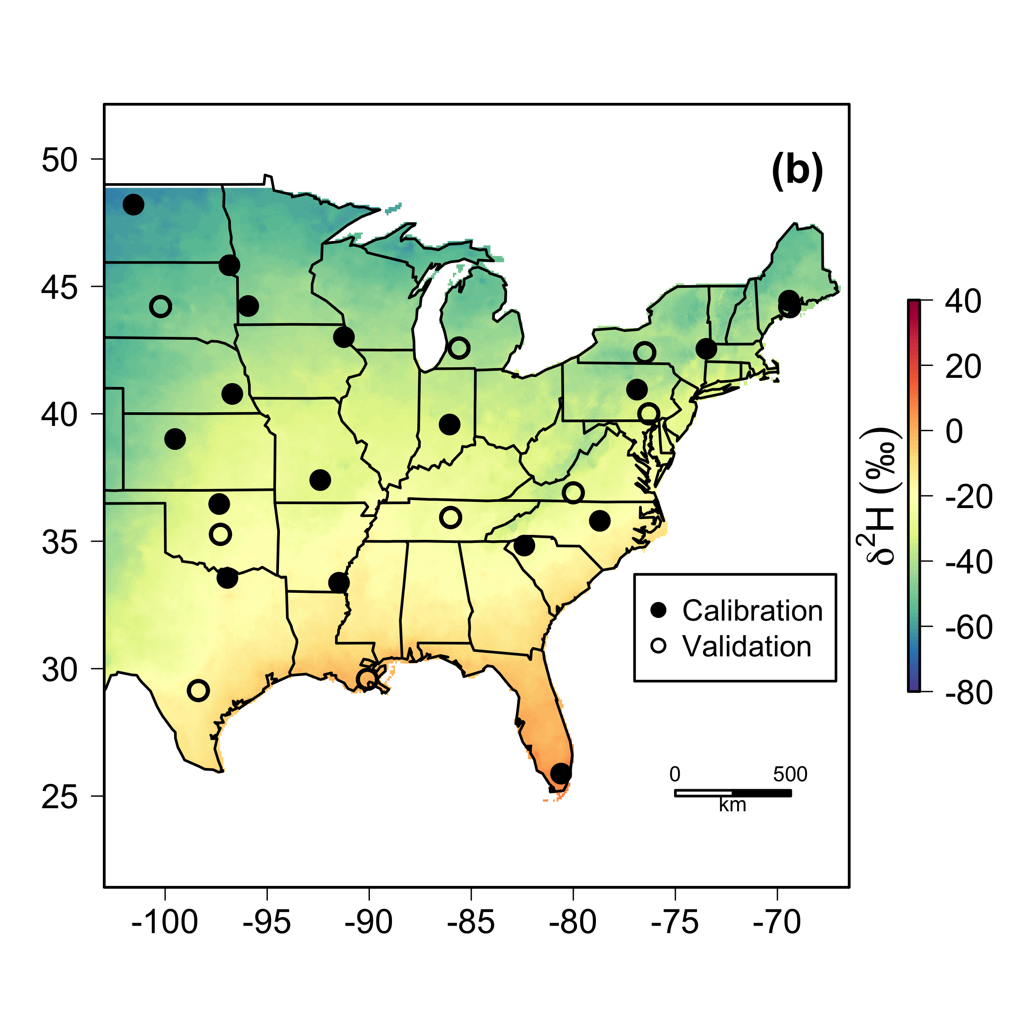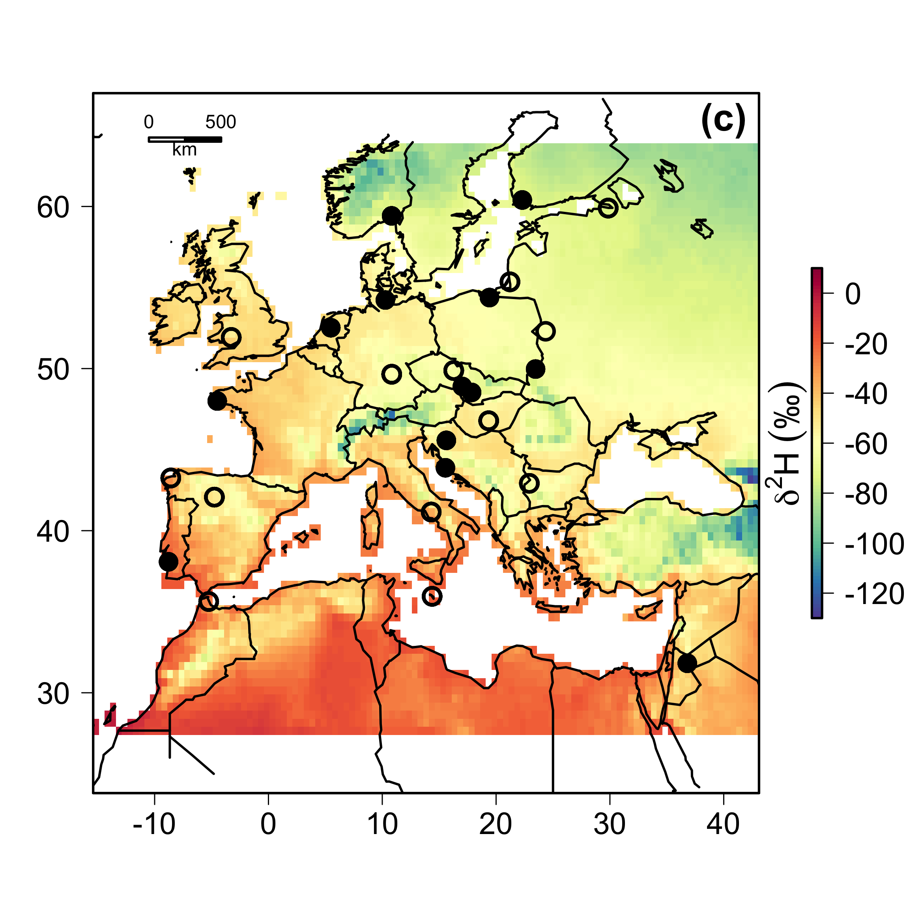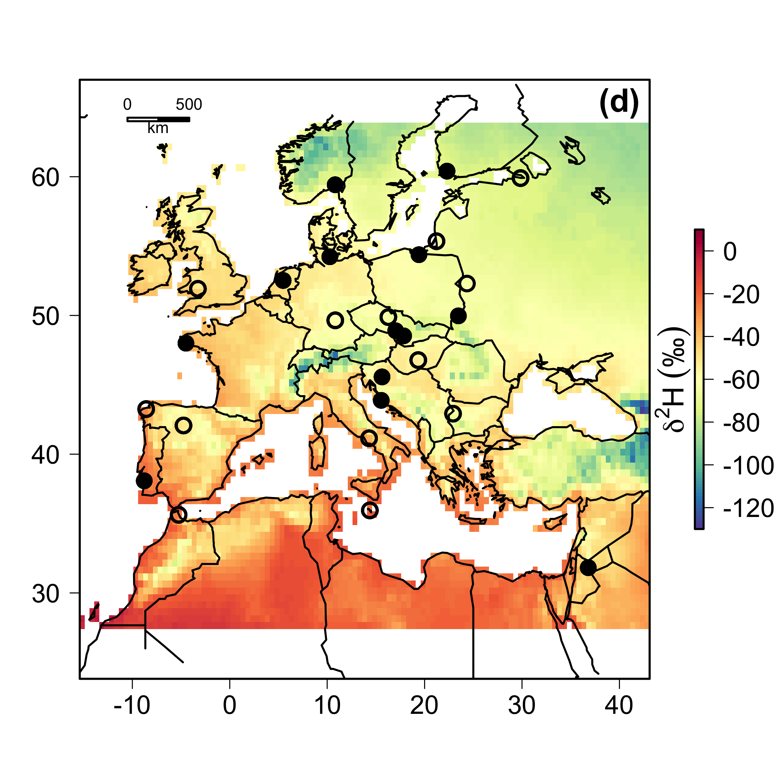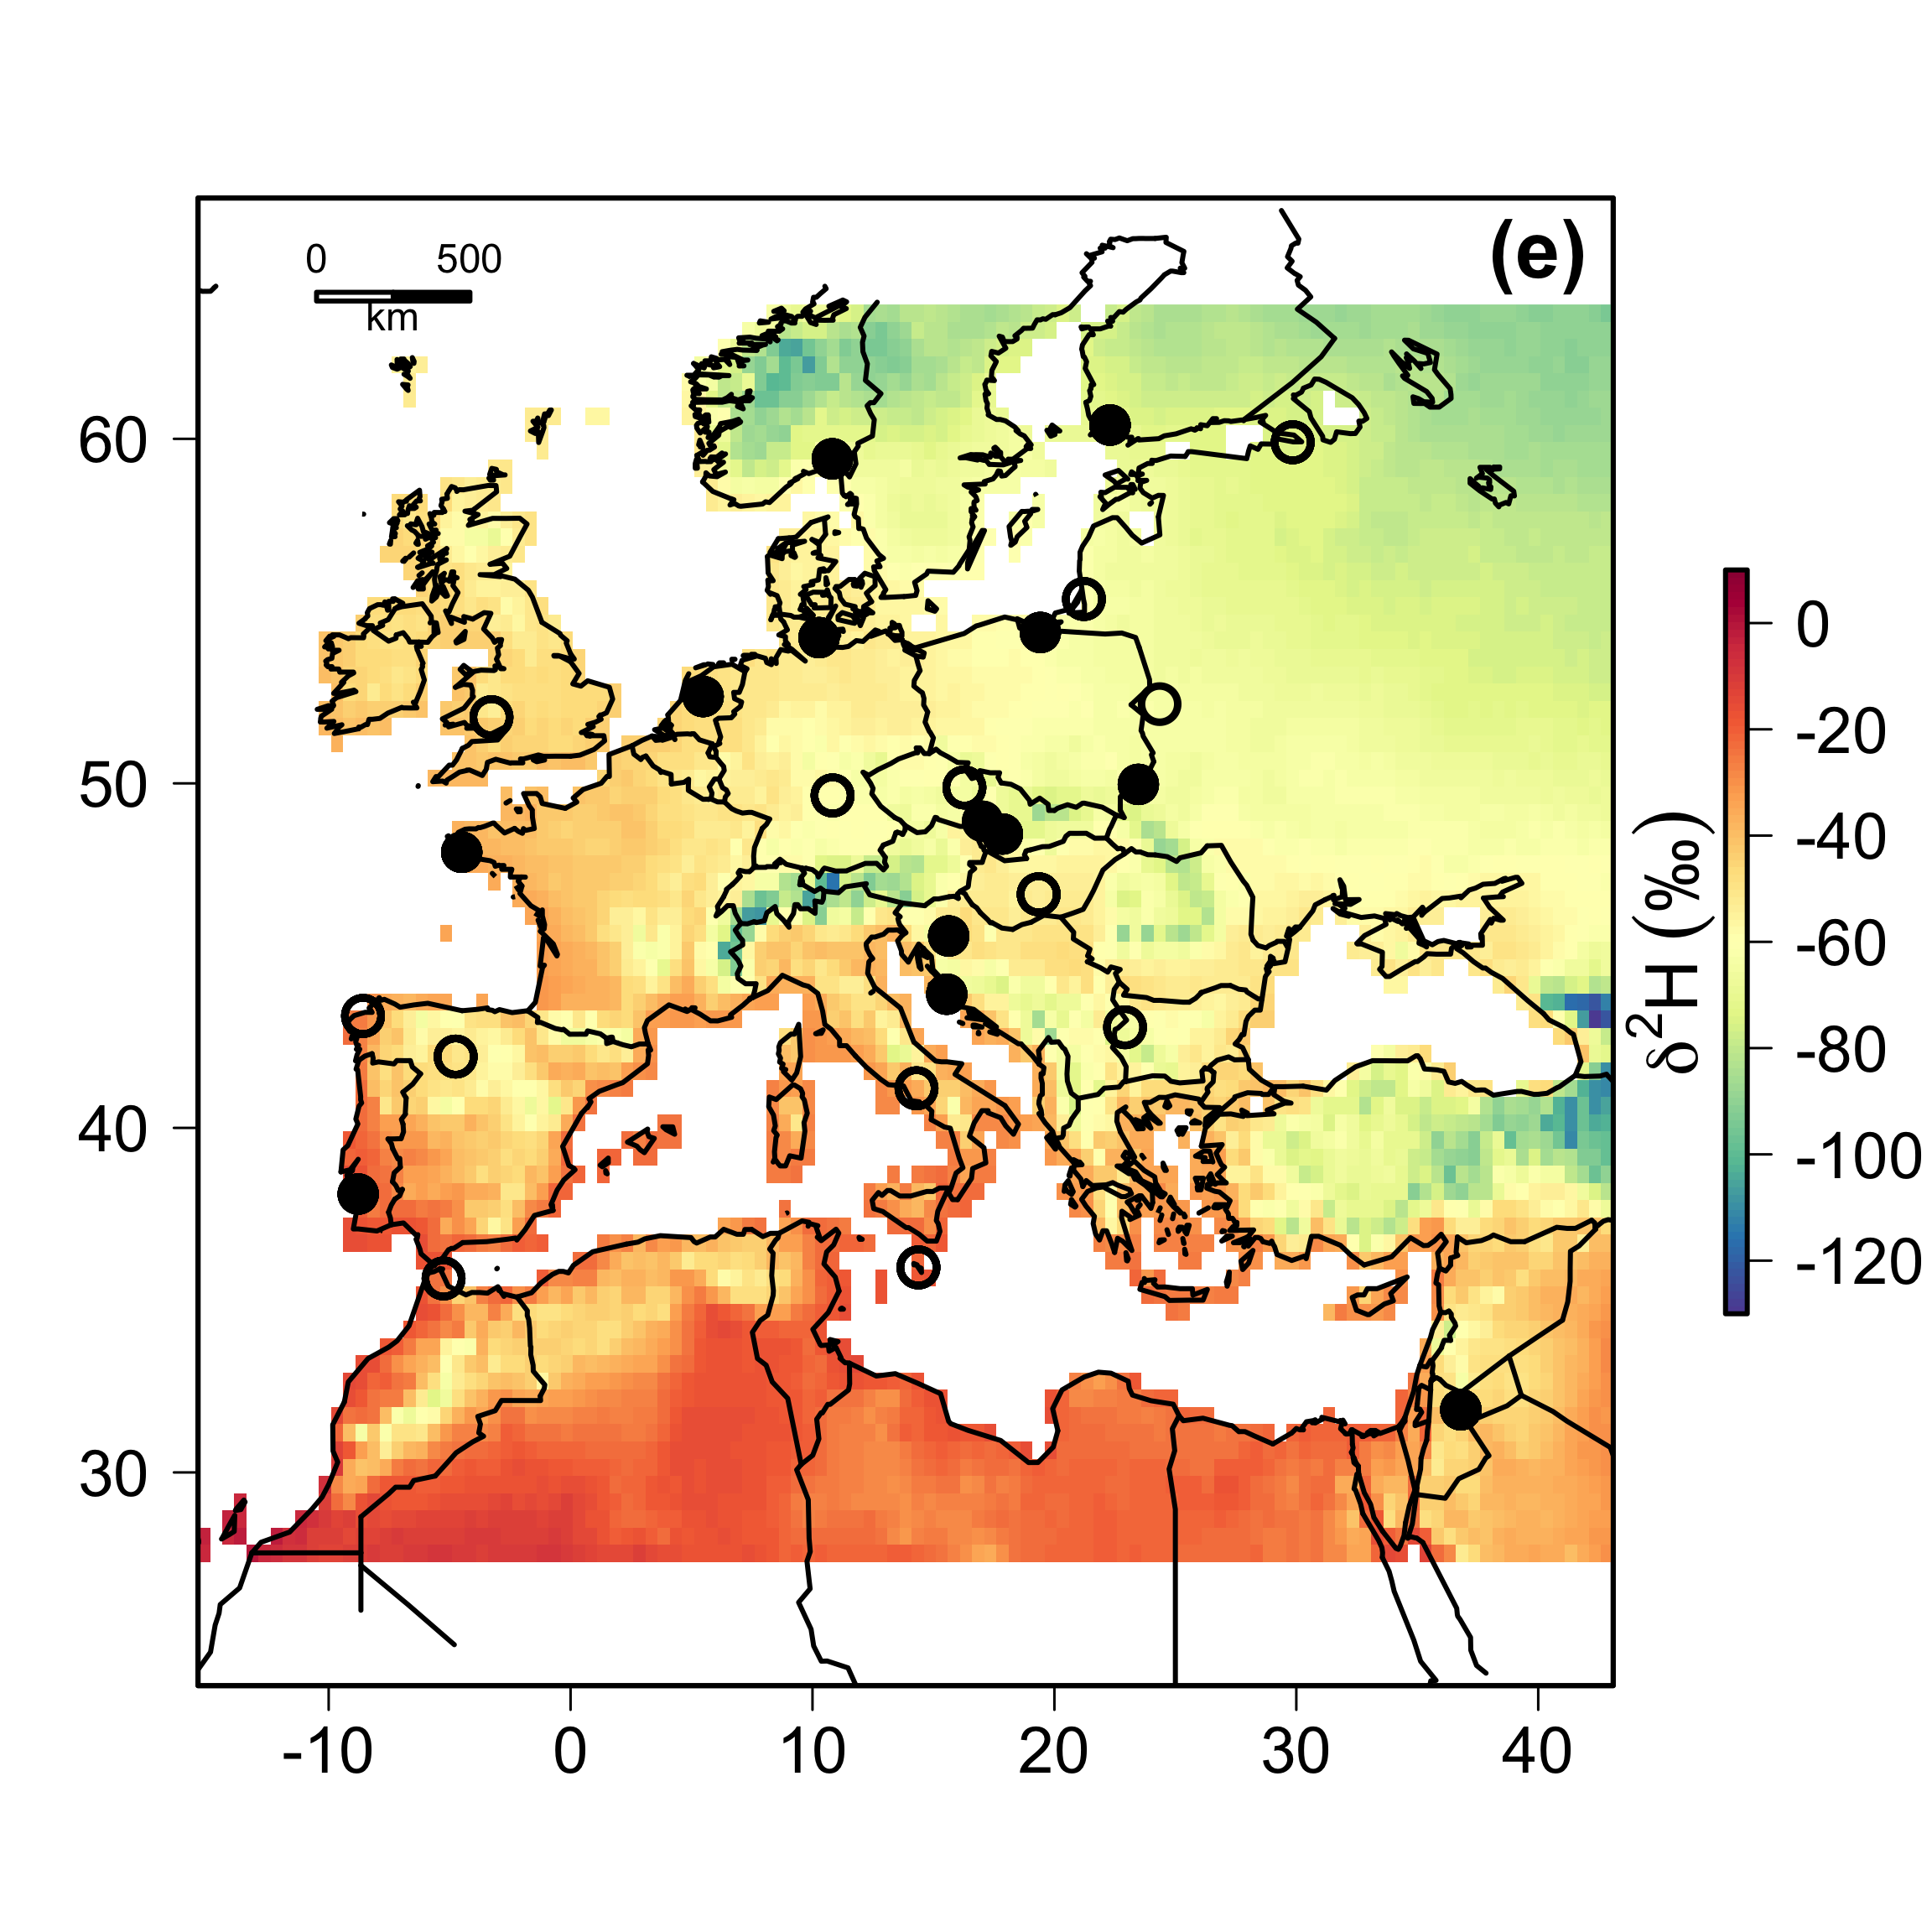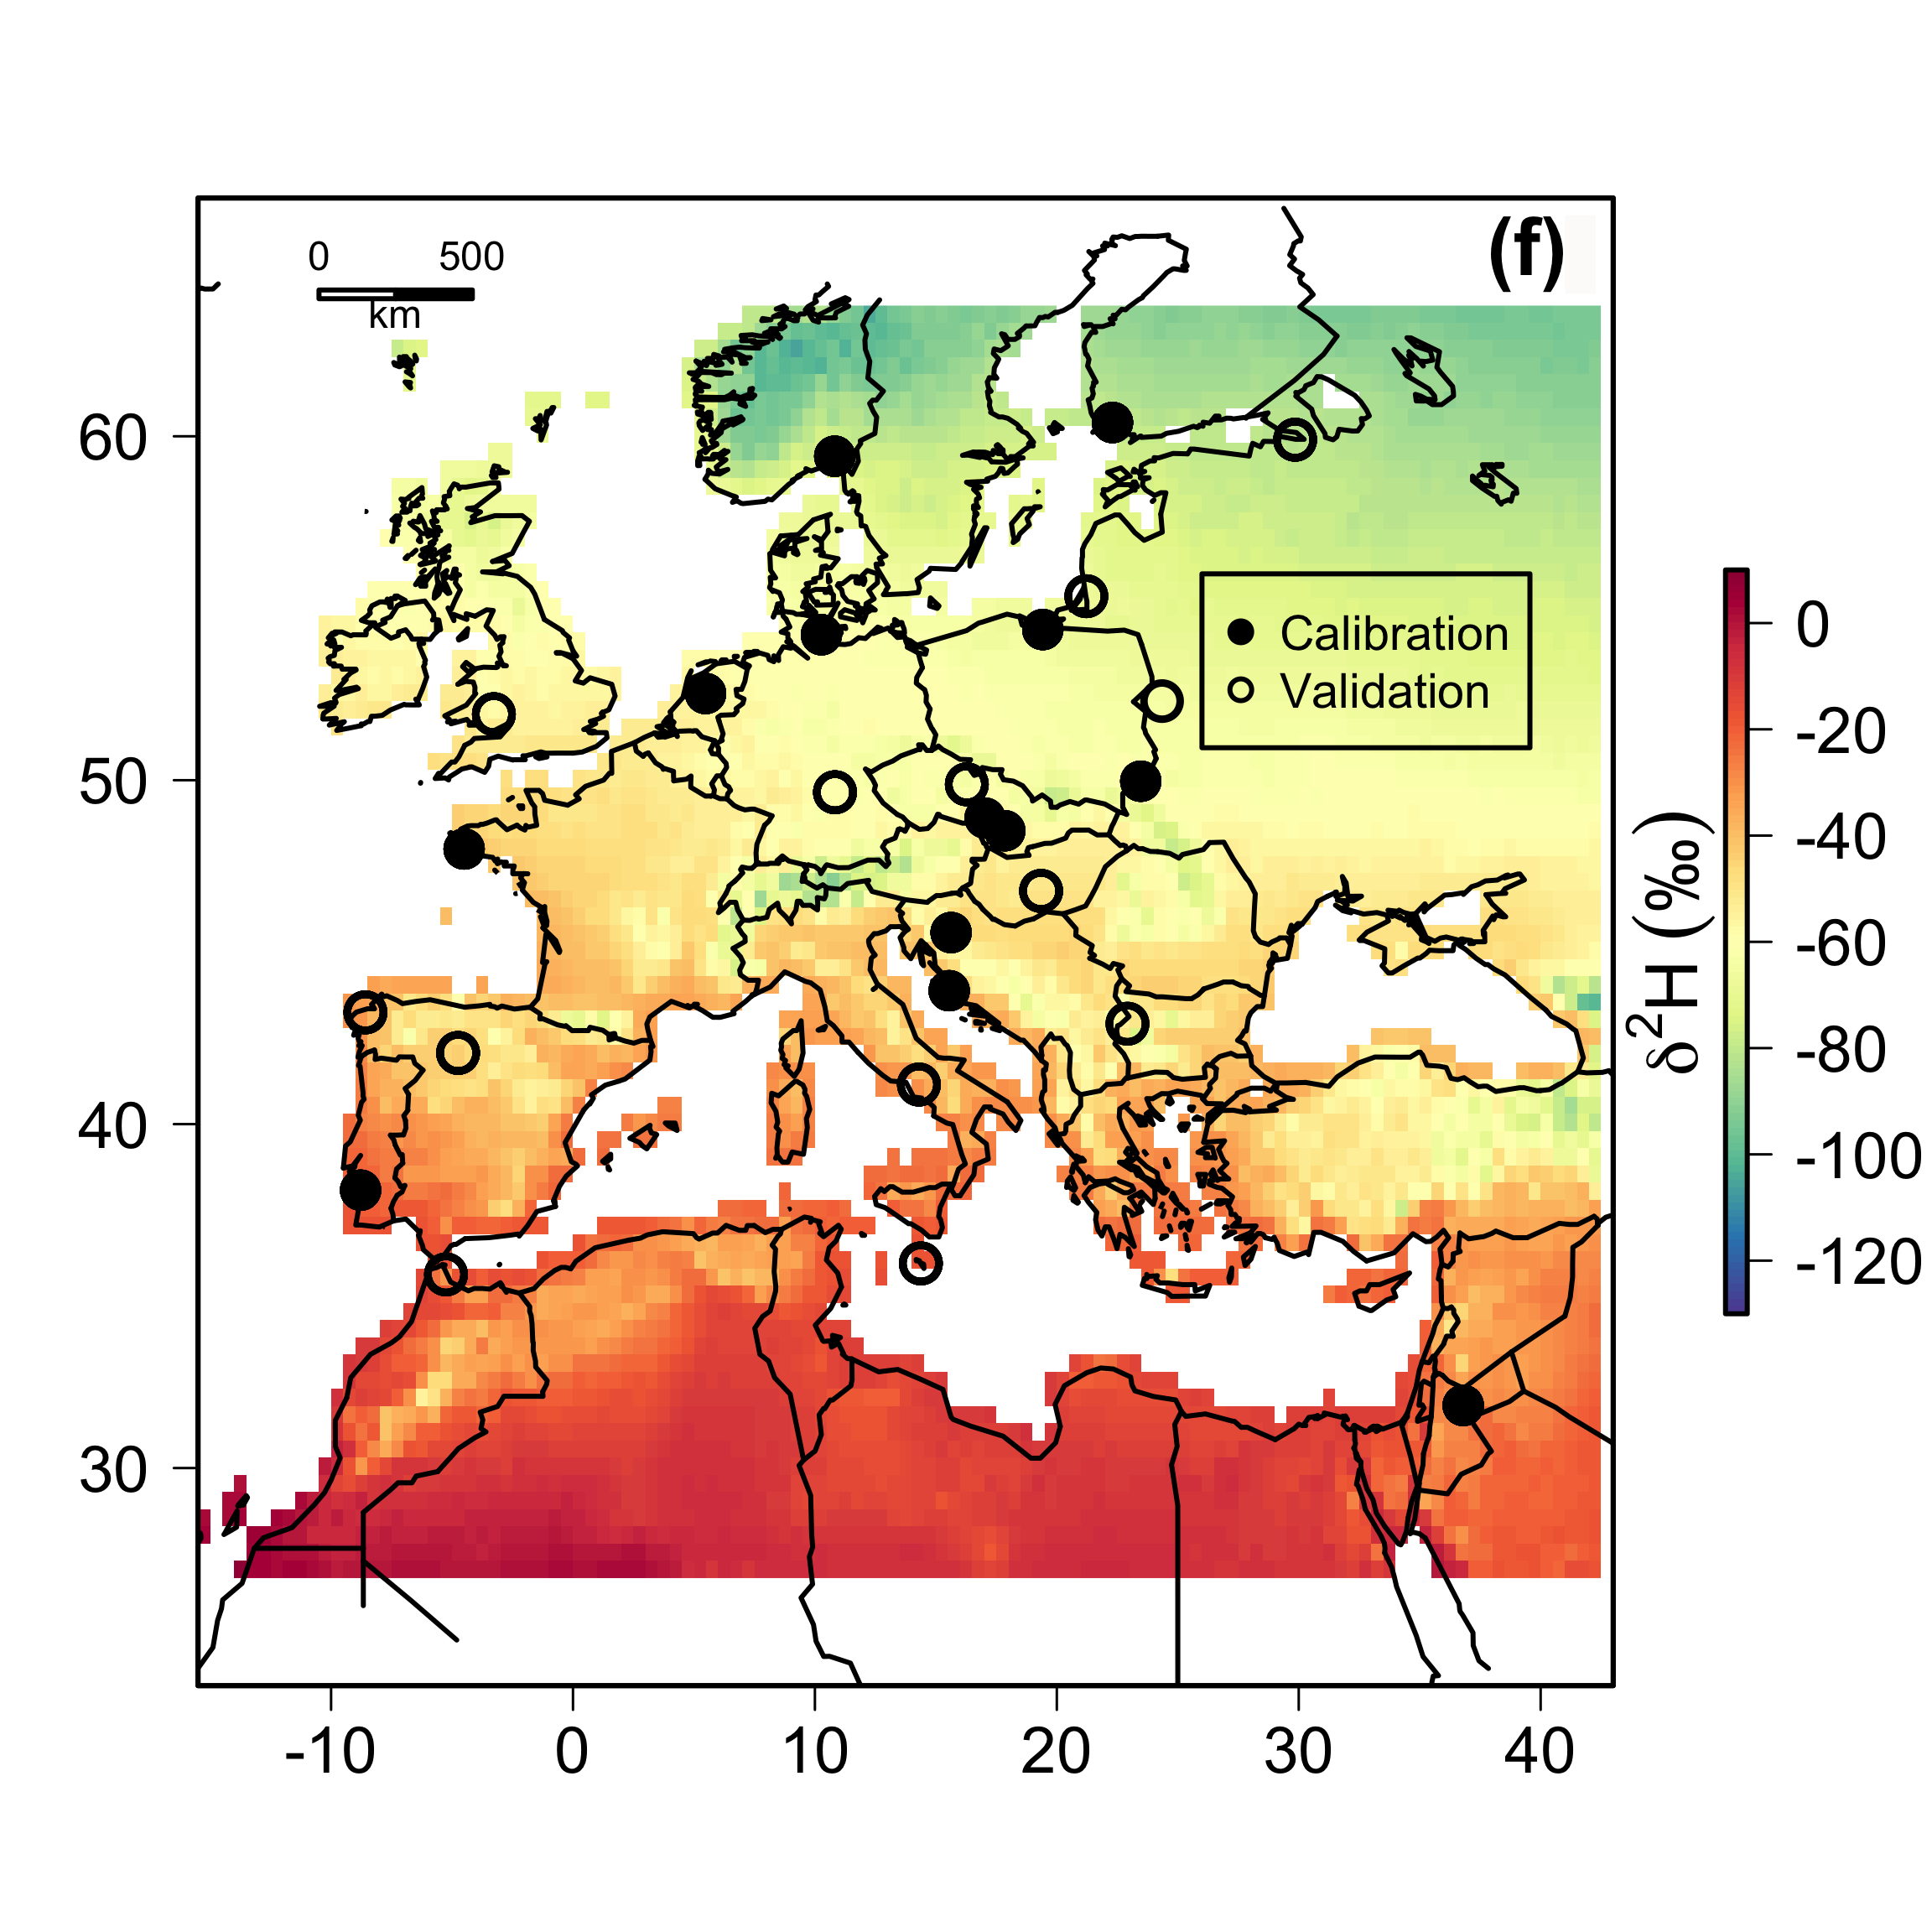

**Fig. S1.** Values of **2H in precipitation across North America and Europe representing short- (a, c, d, e) and long-term (b, f) time periods. (a) 1996, (b) 1960-2000, (c) 2004, (d) 2005, (e) 2006, (f) 1960-2006. 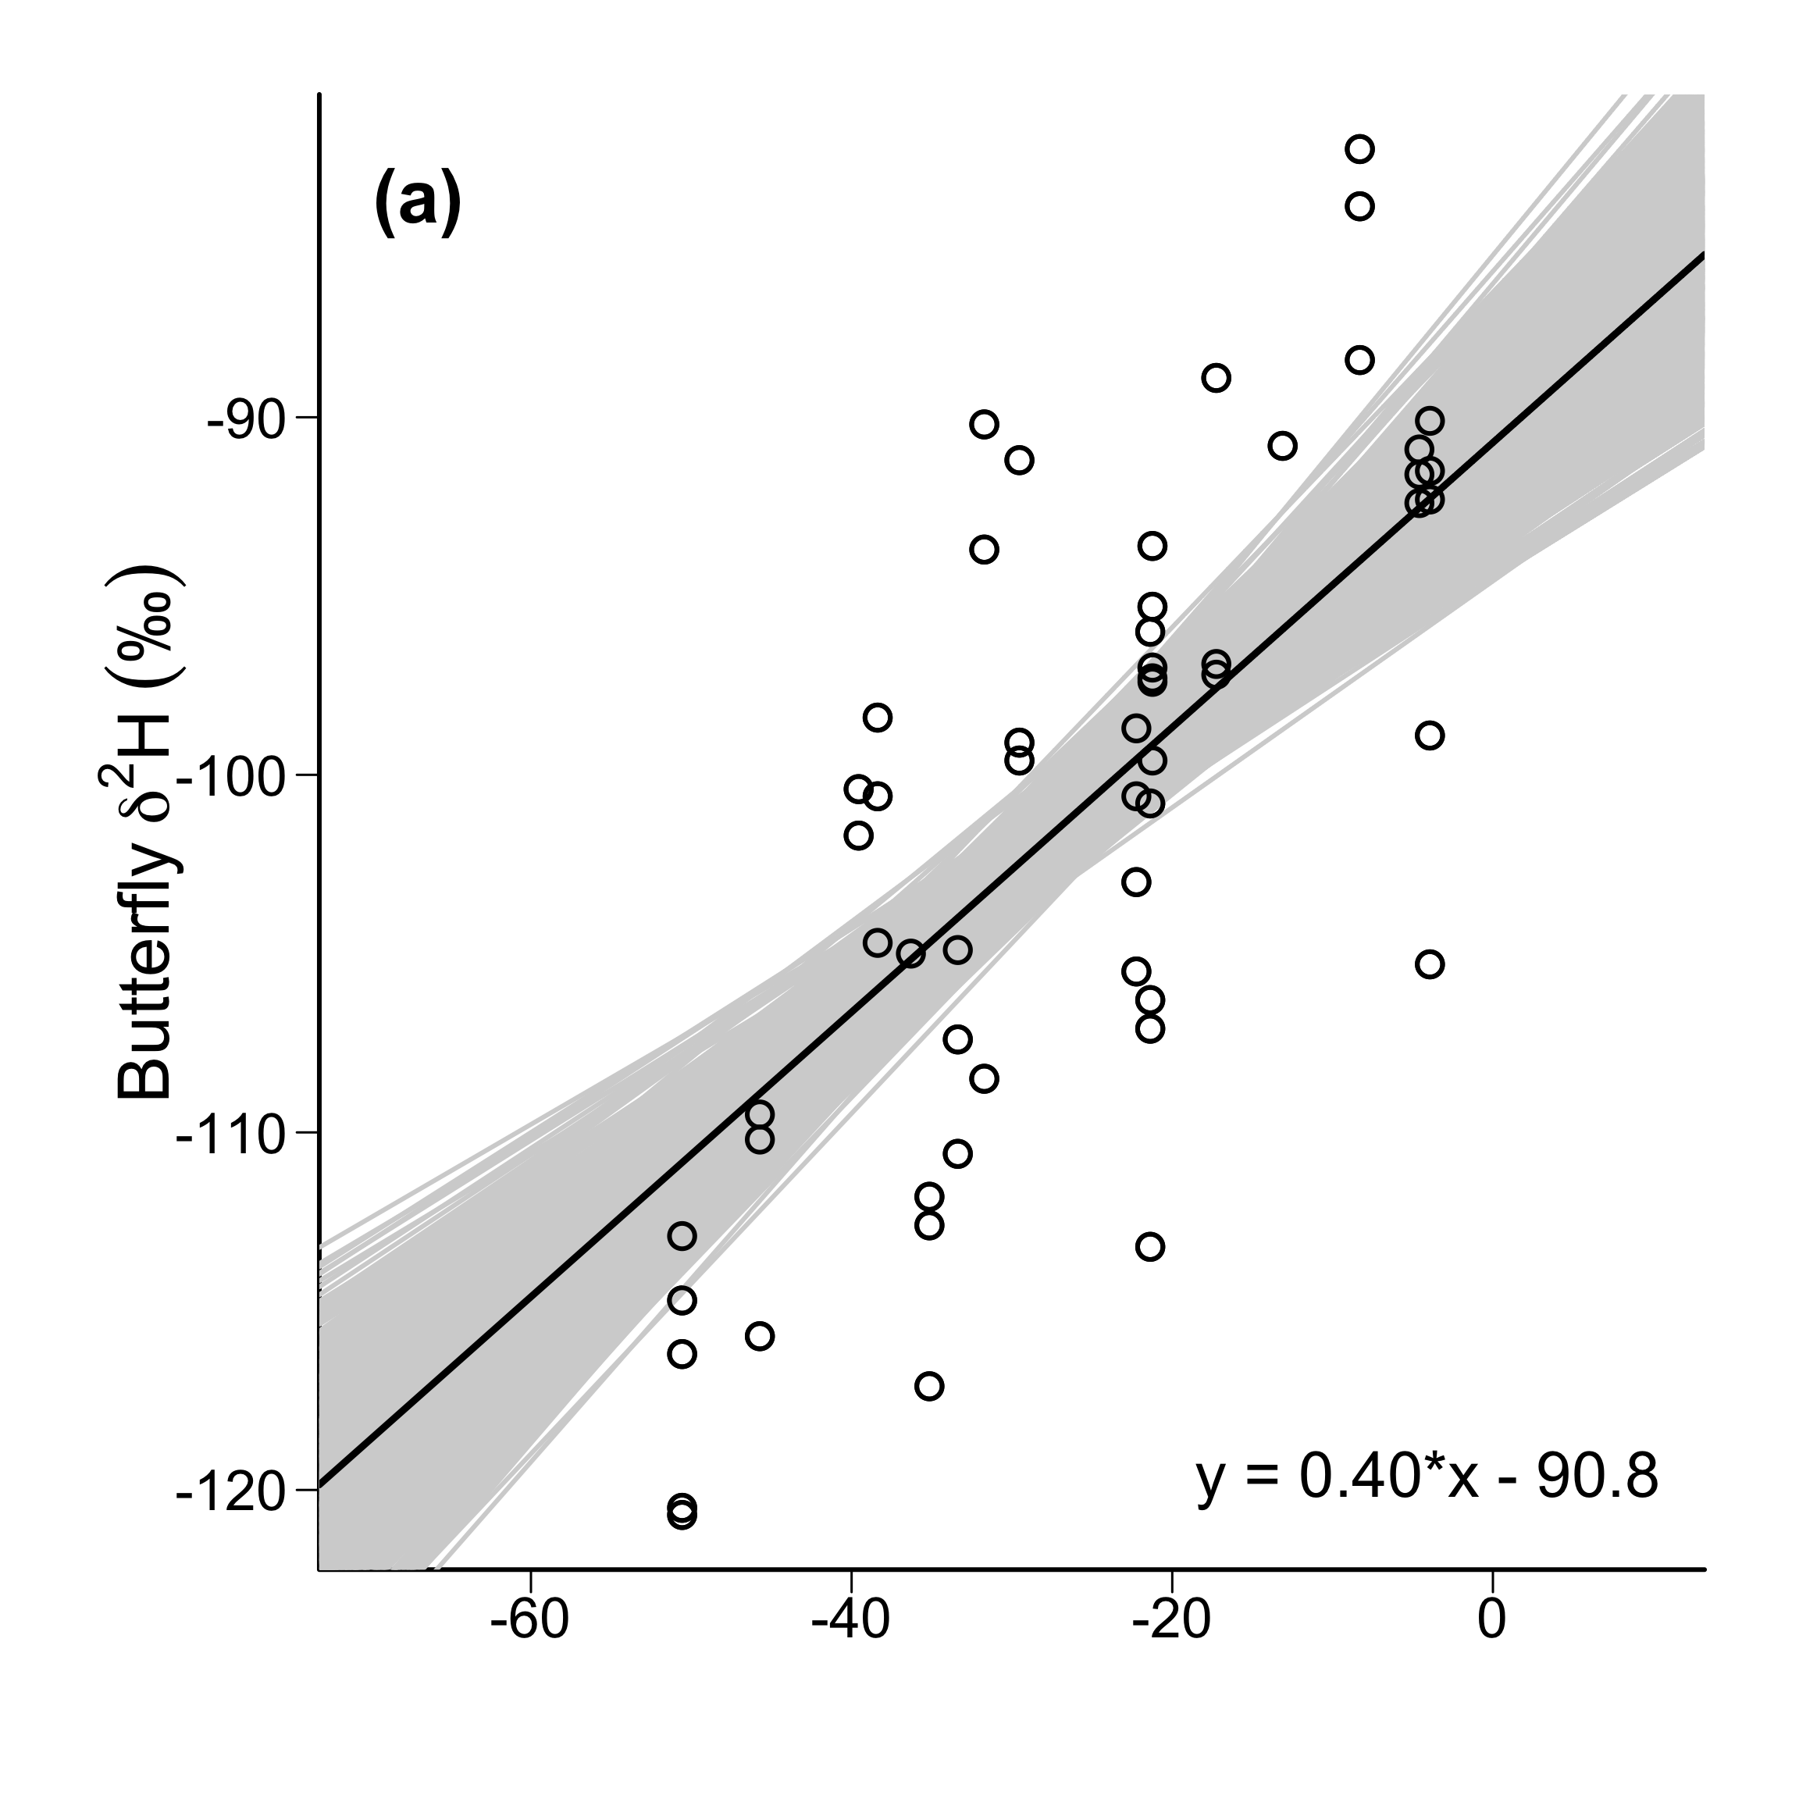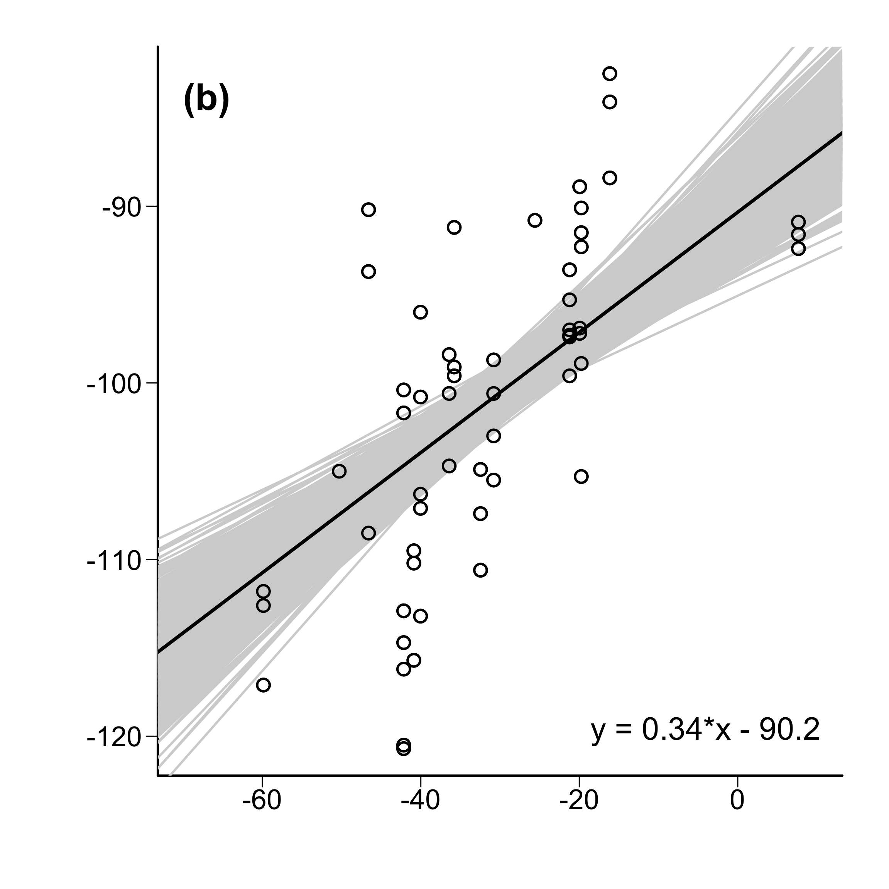

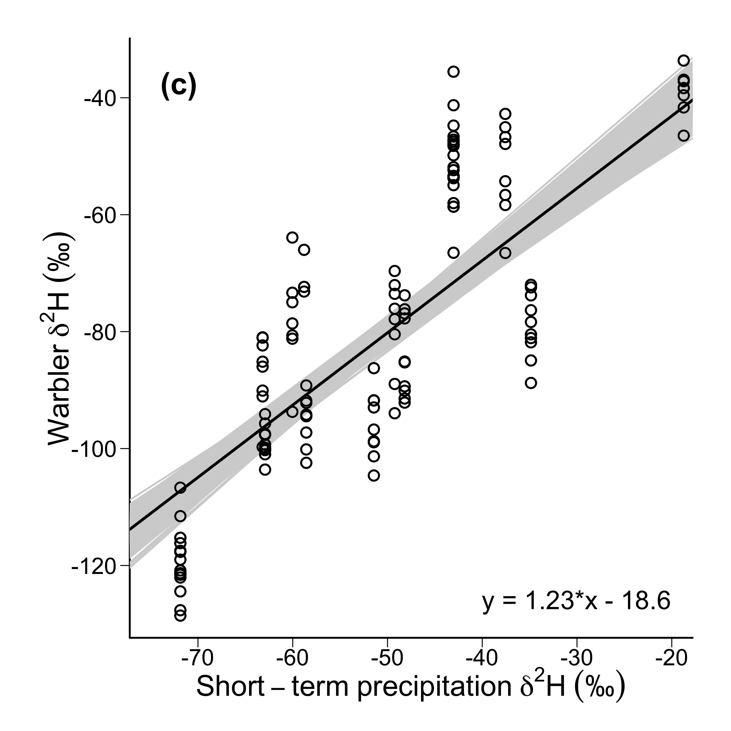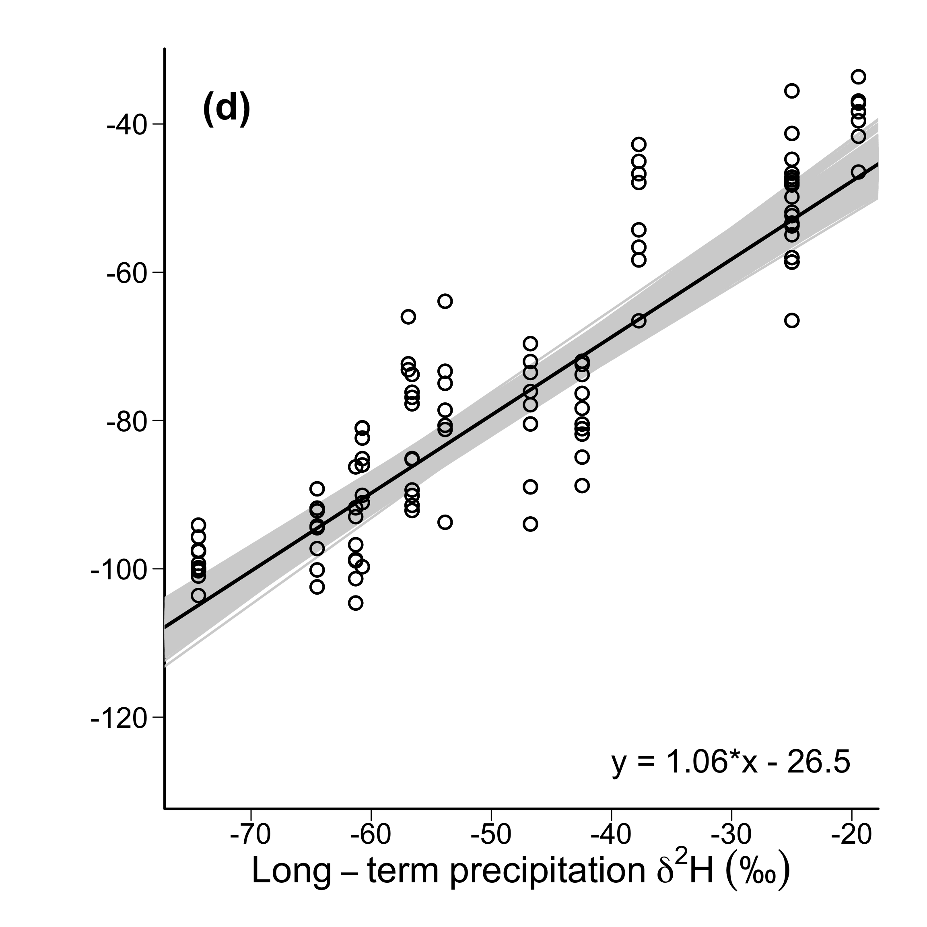

**Fig. S2.** Rescaling functions used to convert precipitation isoscapes to tissue-specific isoscapes with ordinary least squares regression. The precipitation values were extracted from the short- and long-term isoscapes from the known origin of the calibration samples. (a) Short-term (*r2* = 0.54) and (b) long-term (*r2* = 0.41) rescaling functions for monarch butterfly wing chitin. (c) Short-term (*r2* = 0.65) and (d) long-term (*r2* = 0.85) rescaling functions for reed warbler feather keratin. Gray lines represent the 1000 simulated regressions.

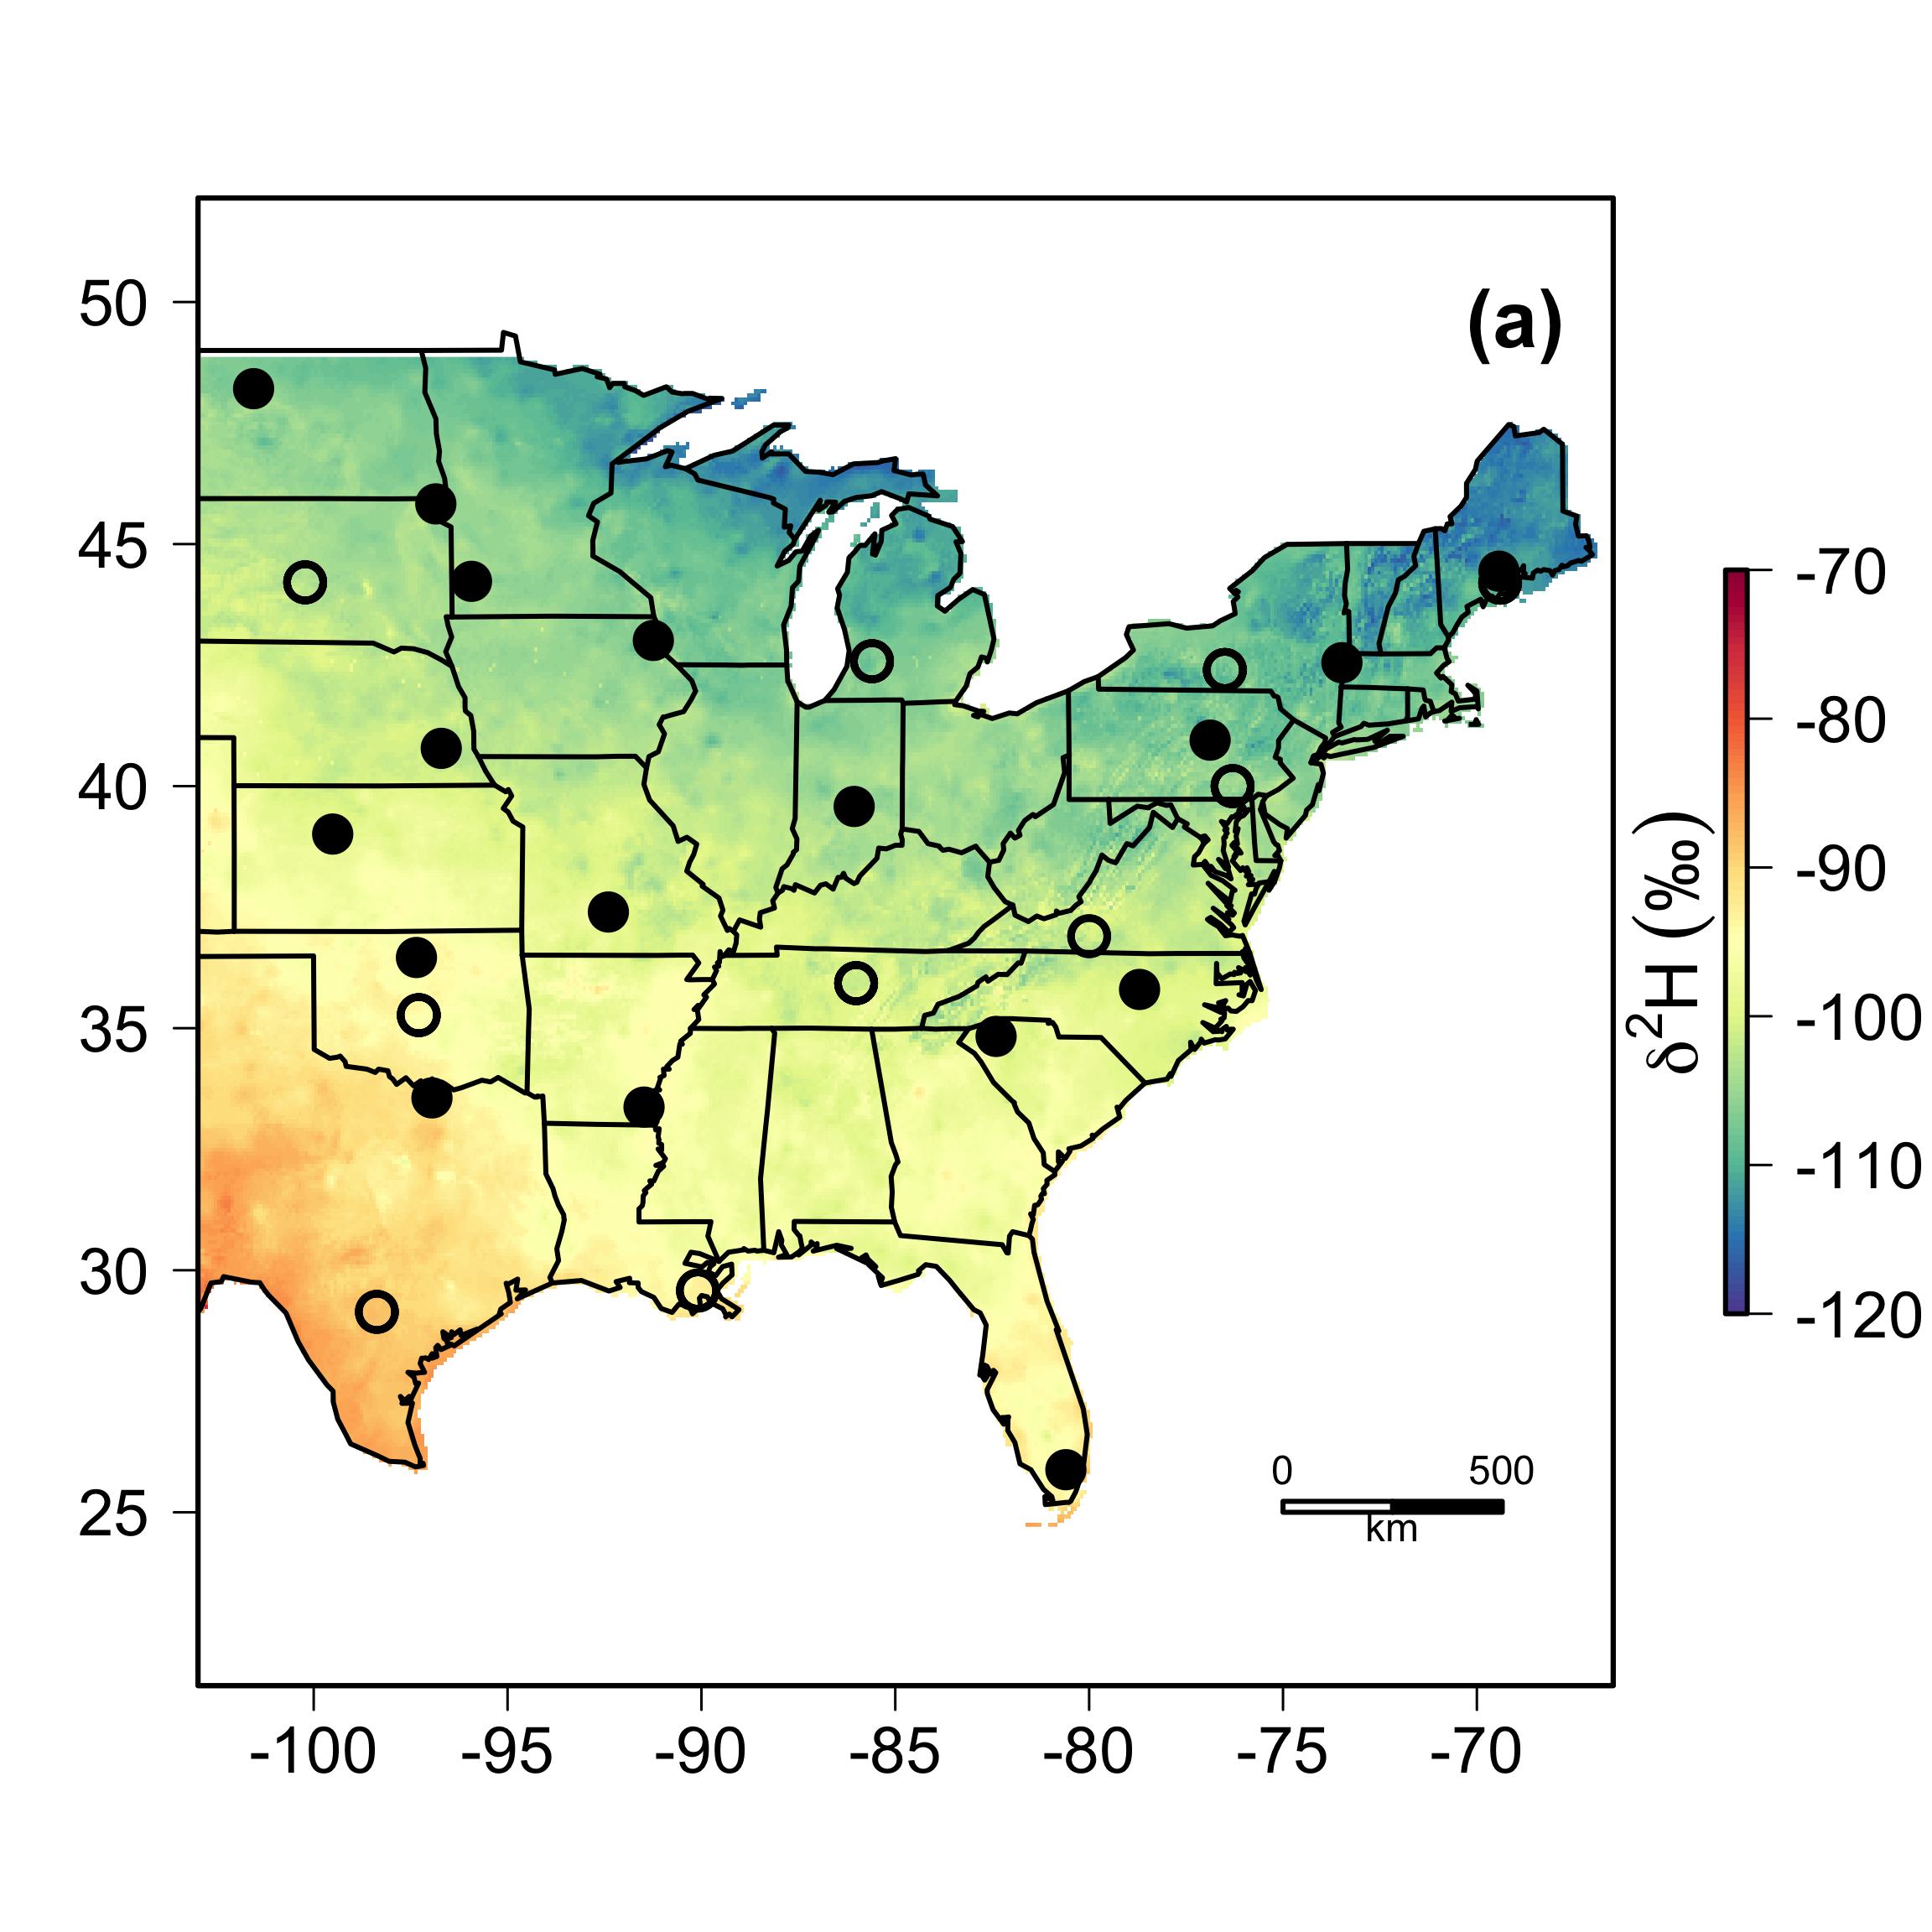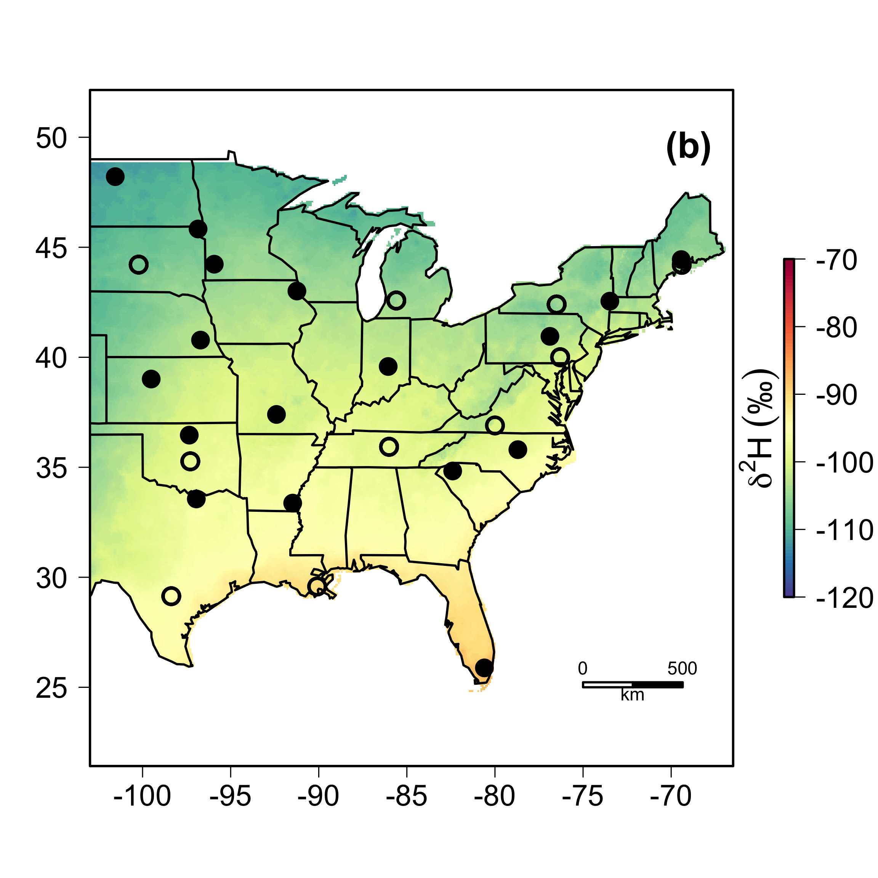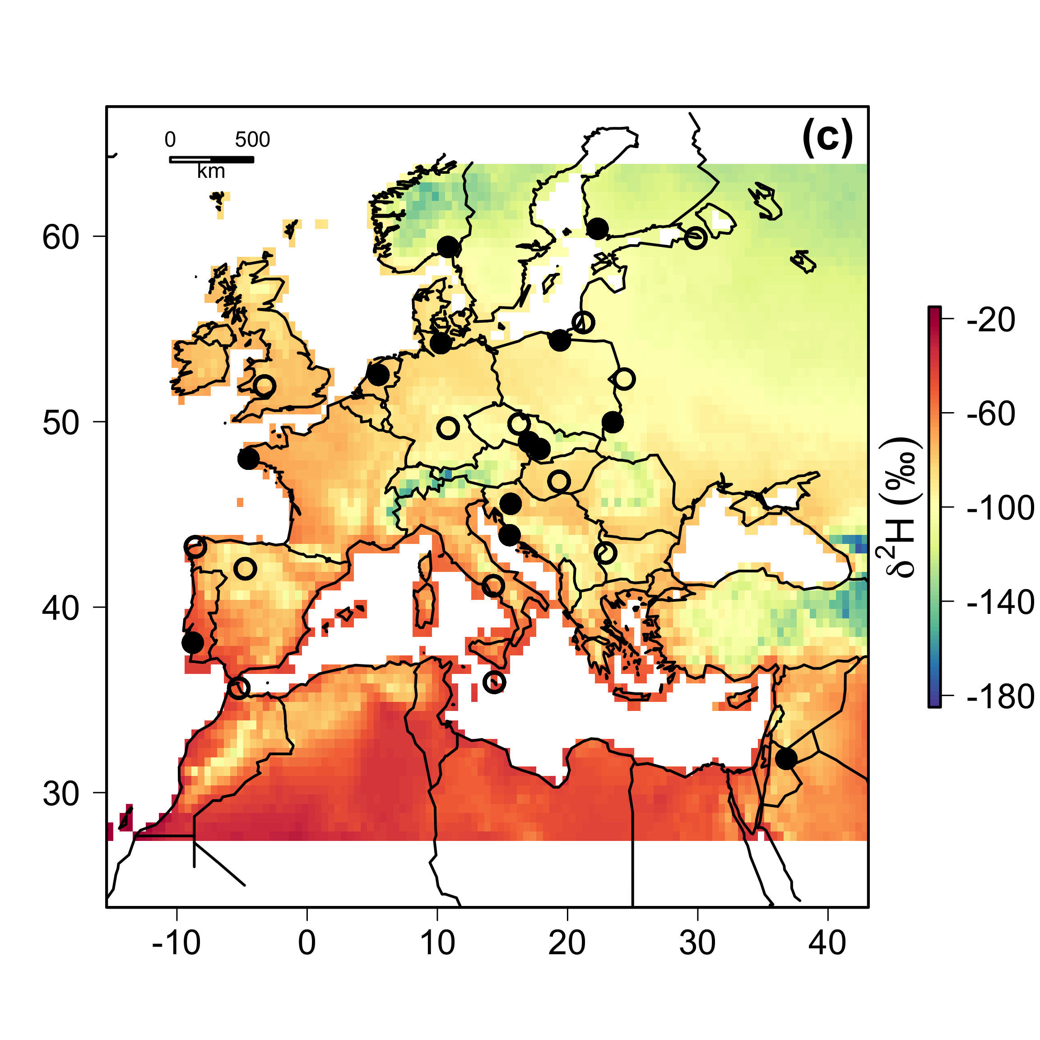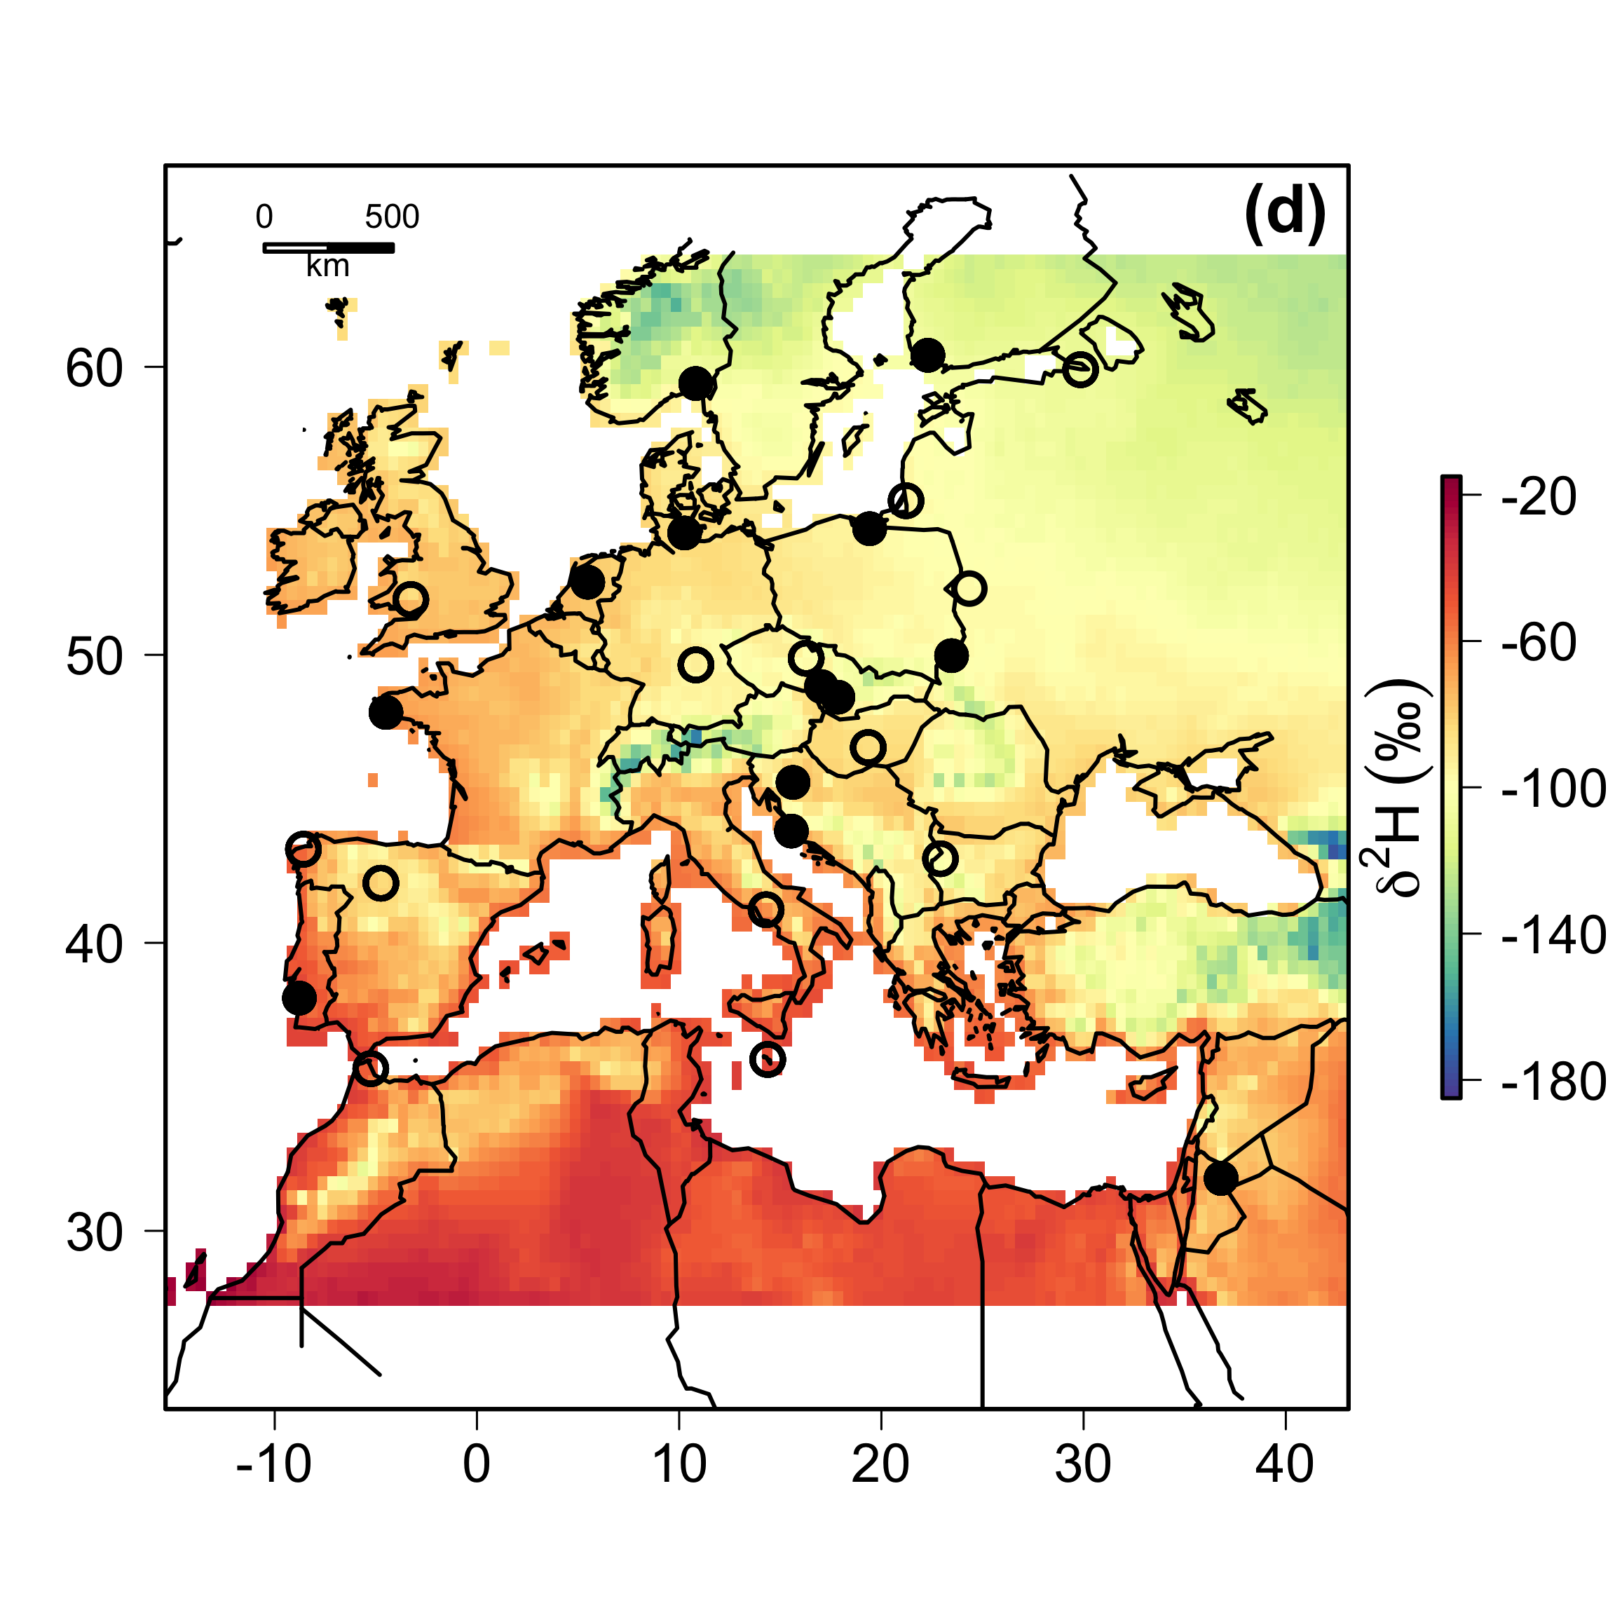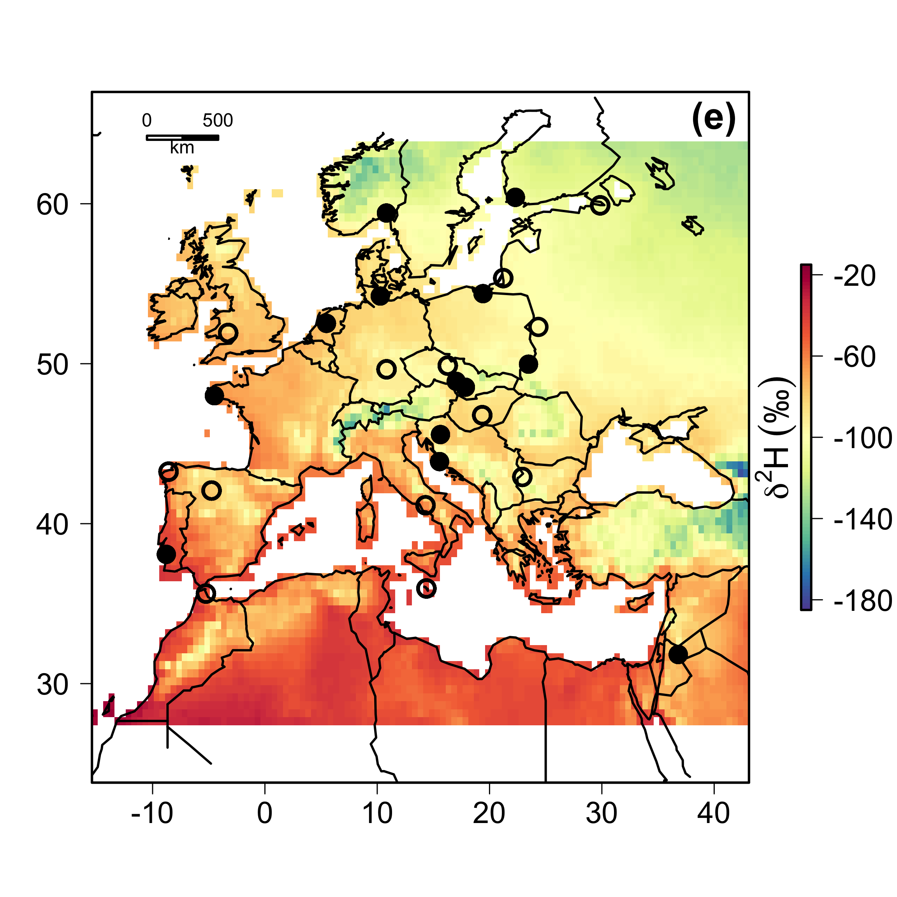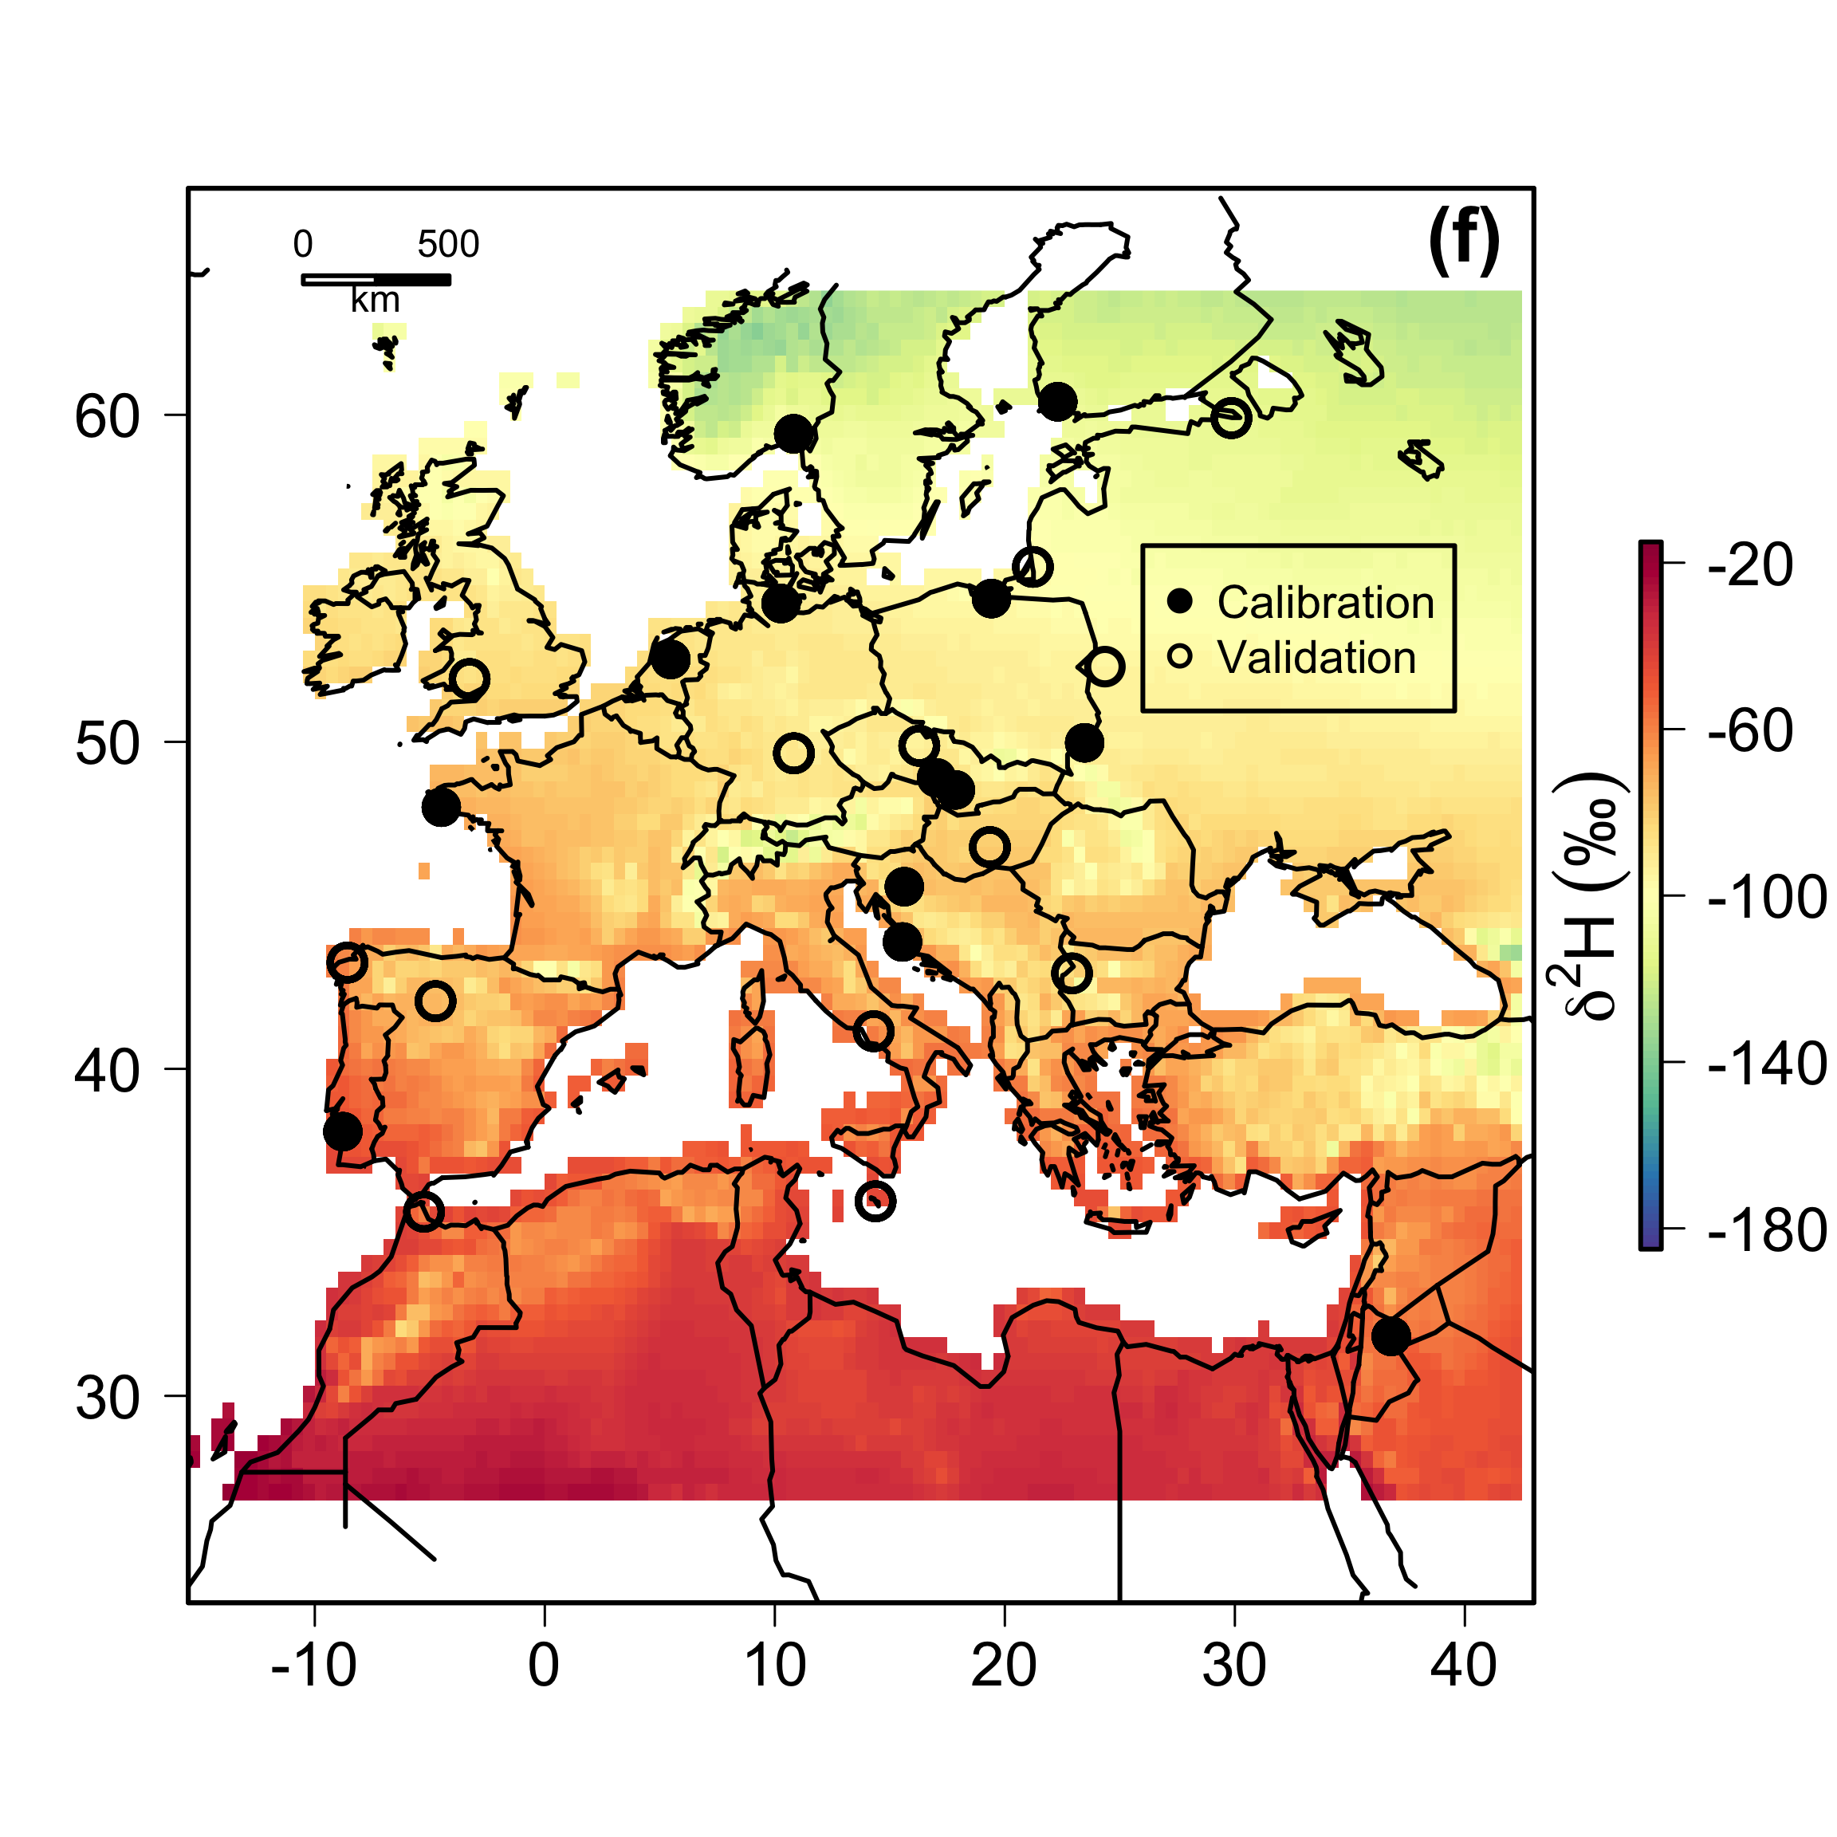

**Fig. S3.** Values of 2Htissue in monarch butterfly (North America) and reed warbler (Europe) tissues representing short- (a, c, d, e) and long-term (b, f) time periods. (a) 1996, (b) 1960-2000, (c) 2004, (d) 2005, (e) 2006, (f) 1960-2006.

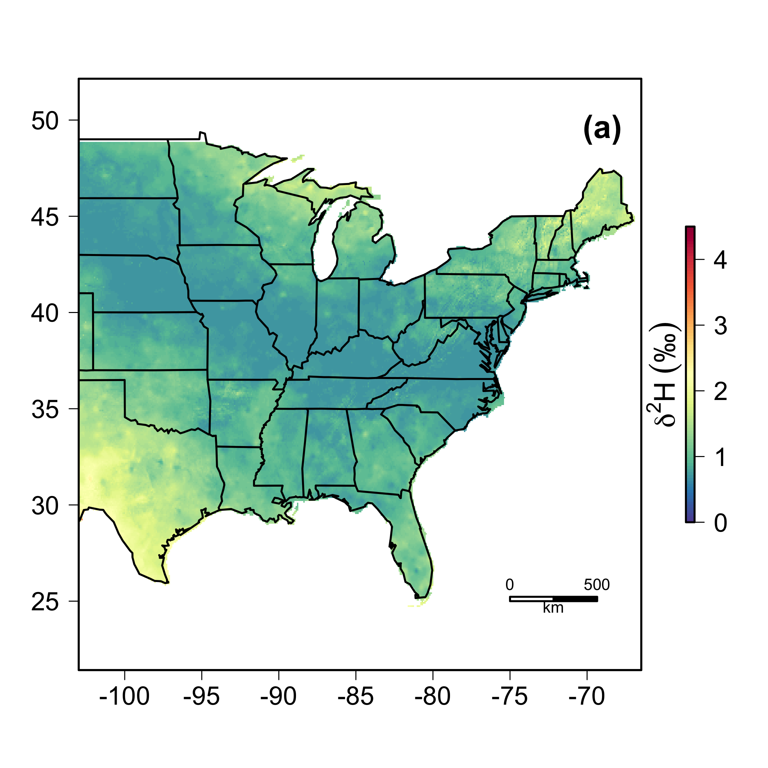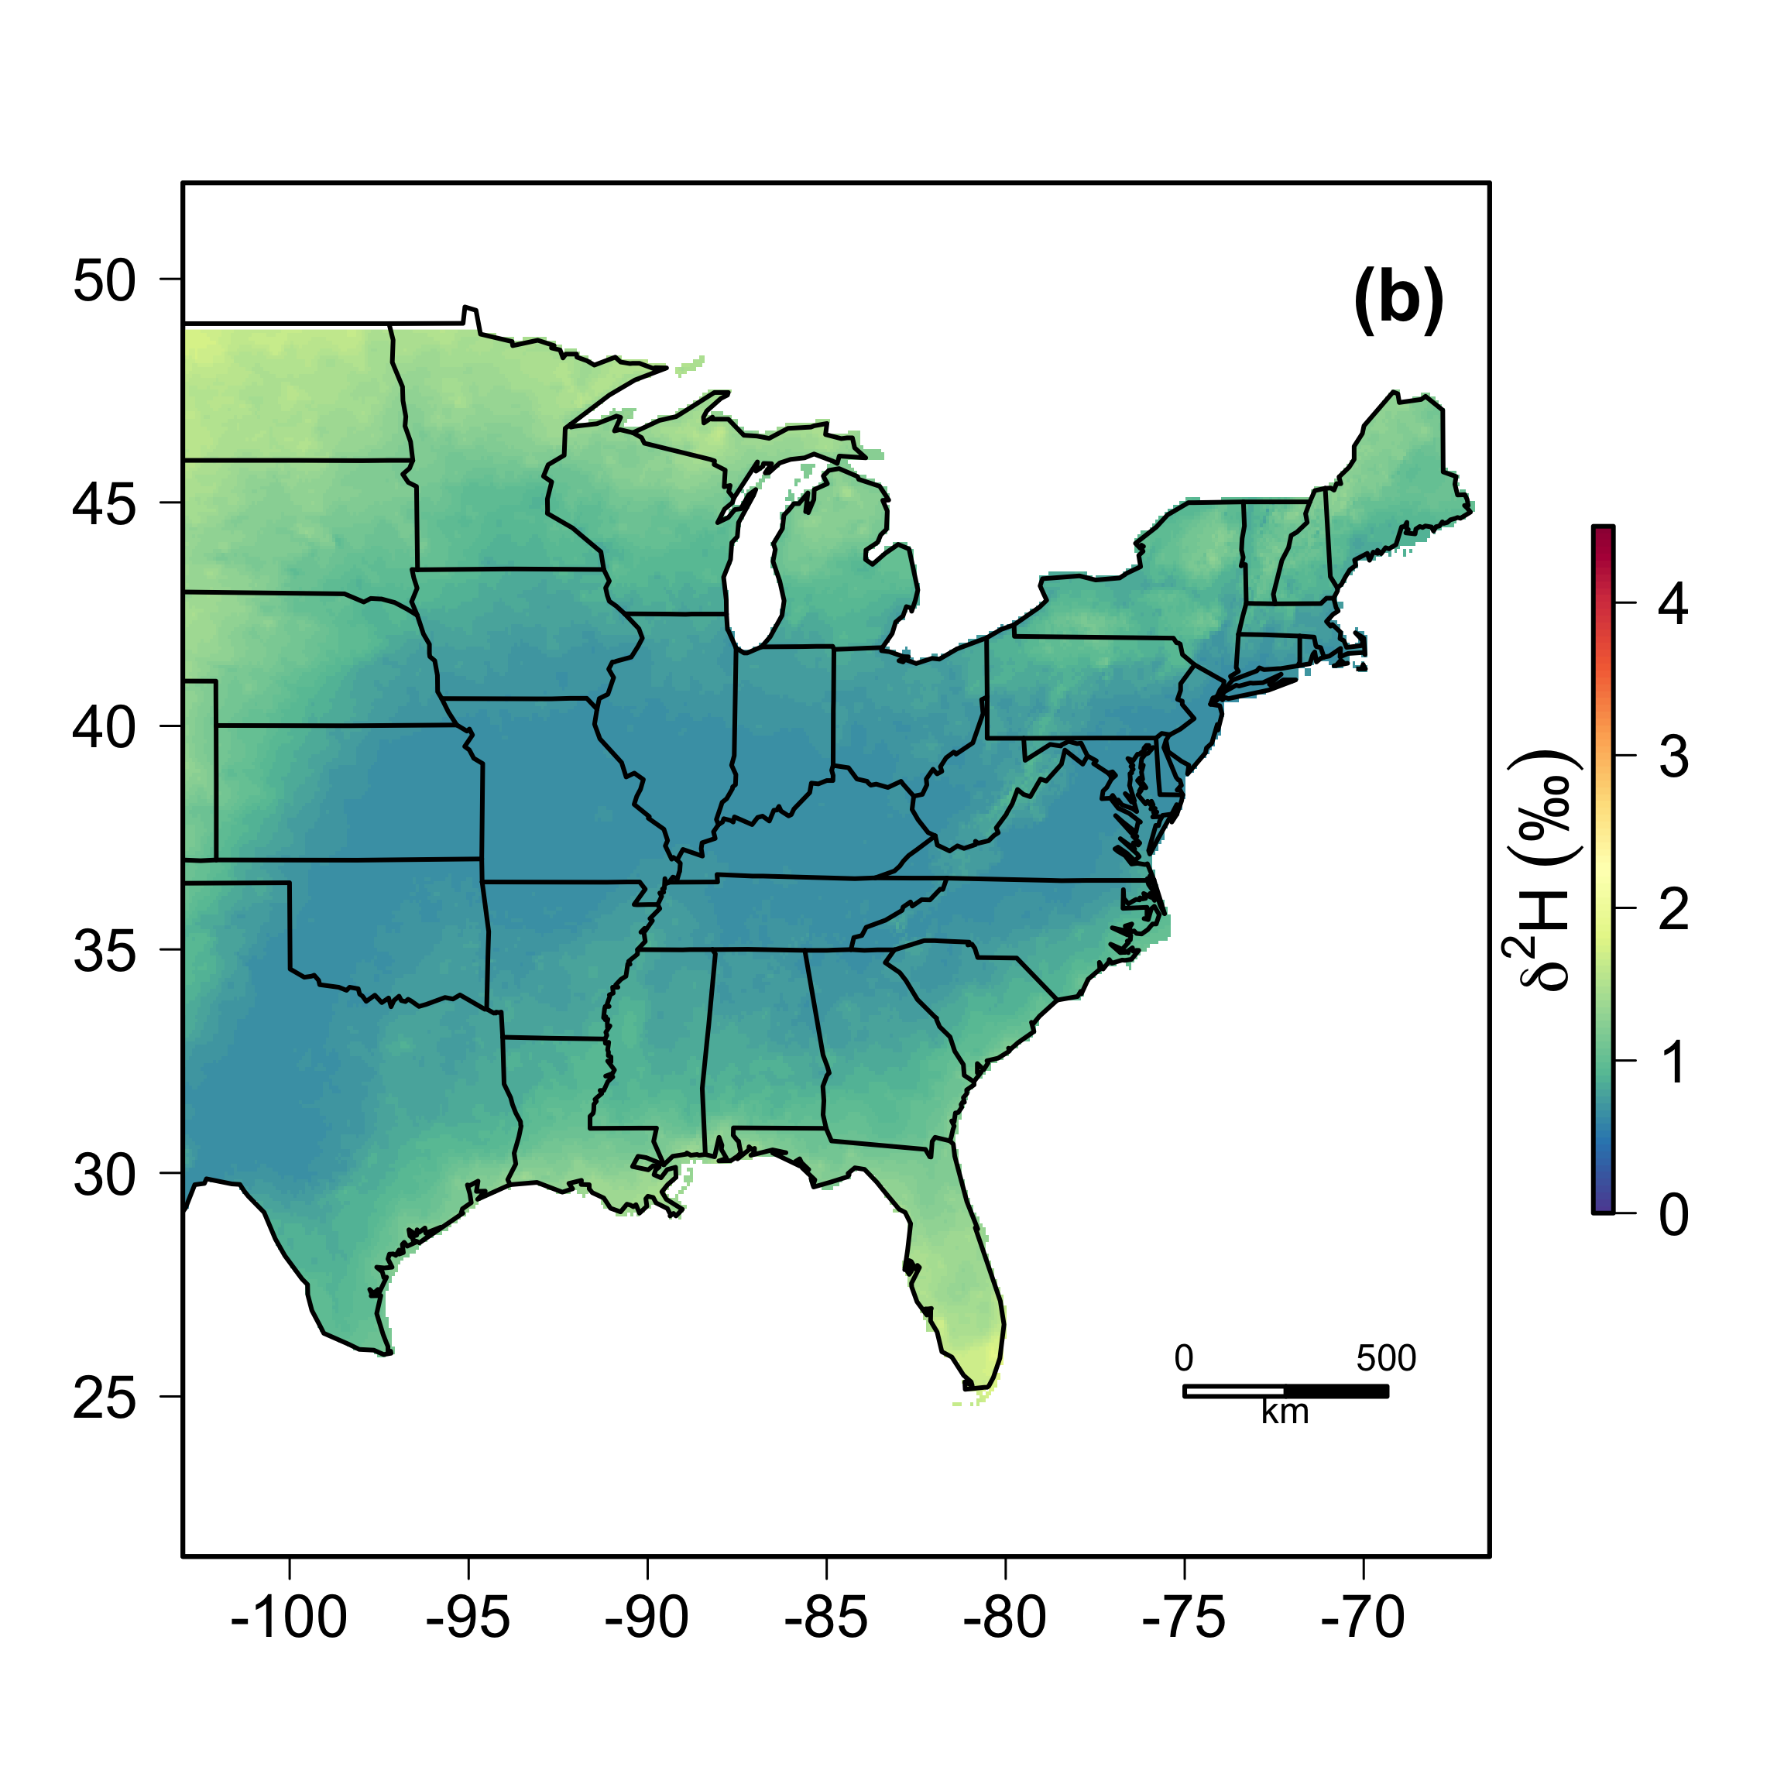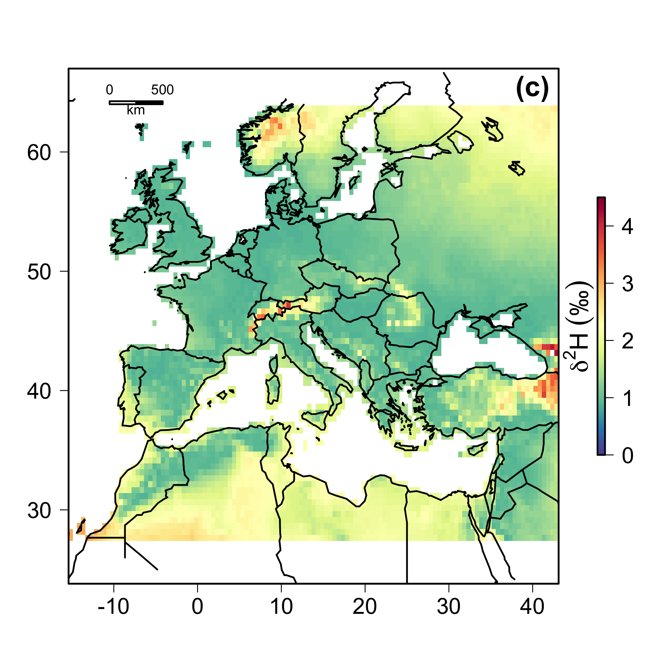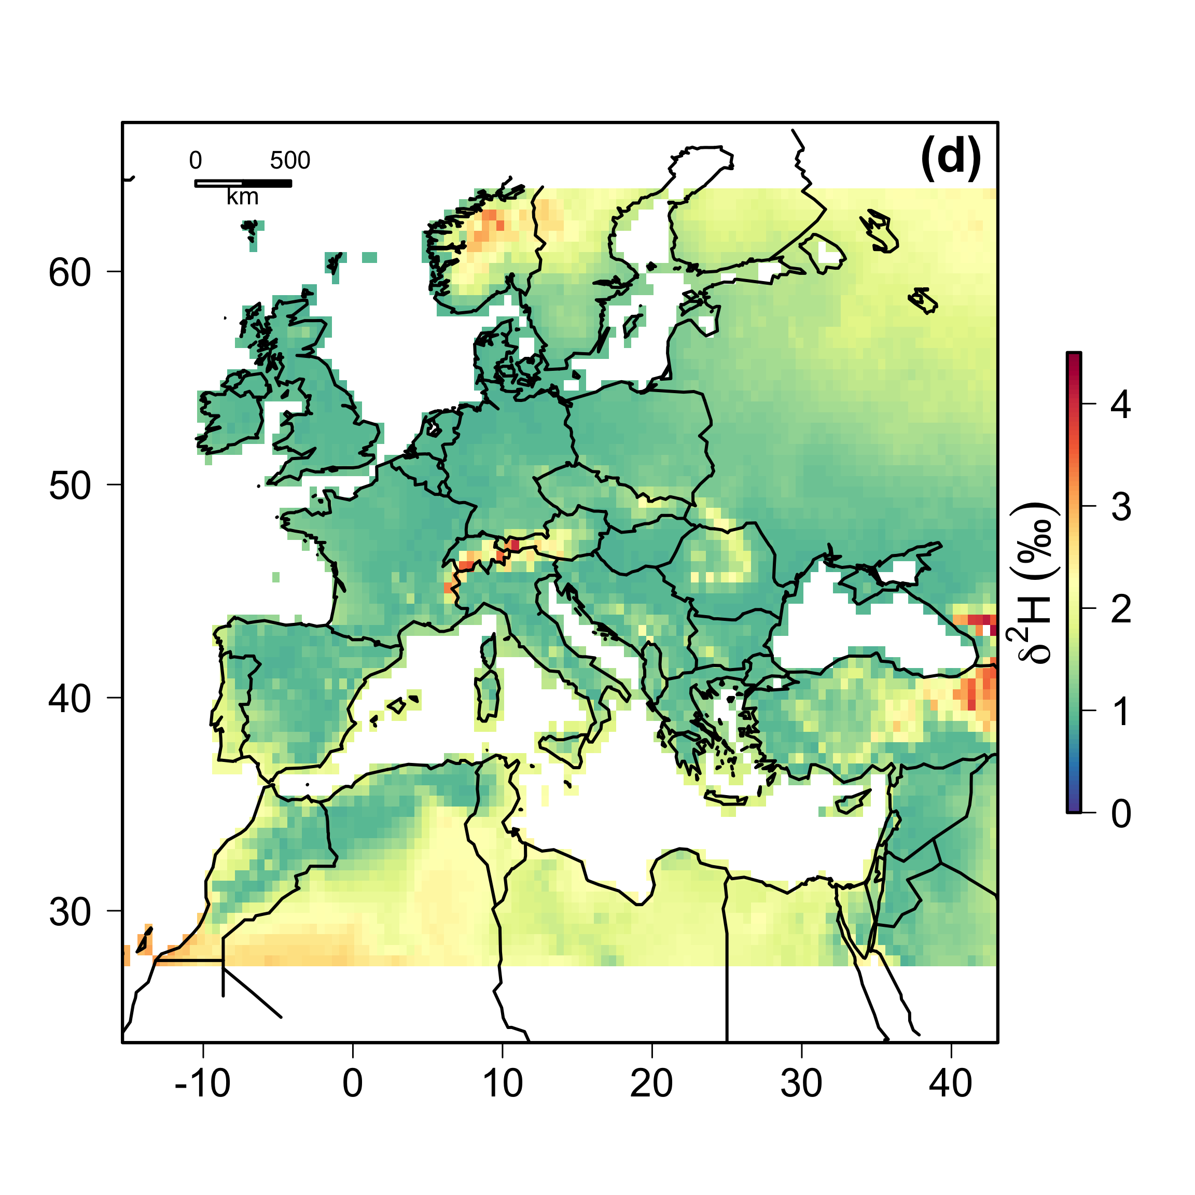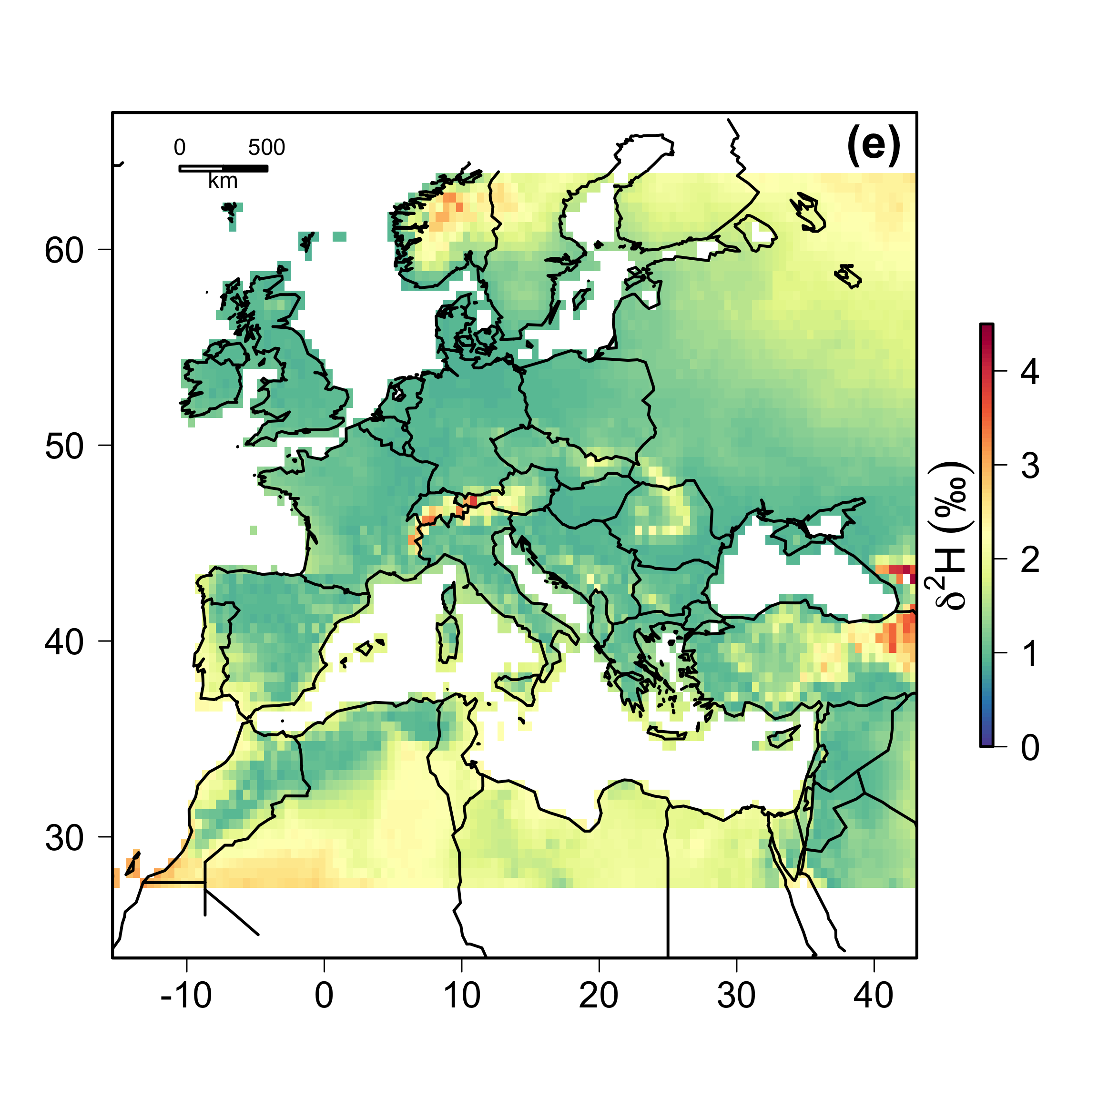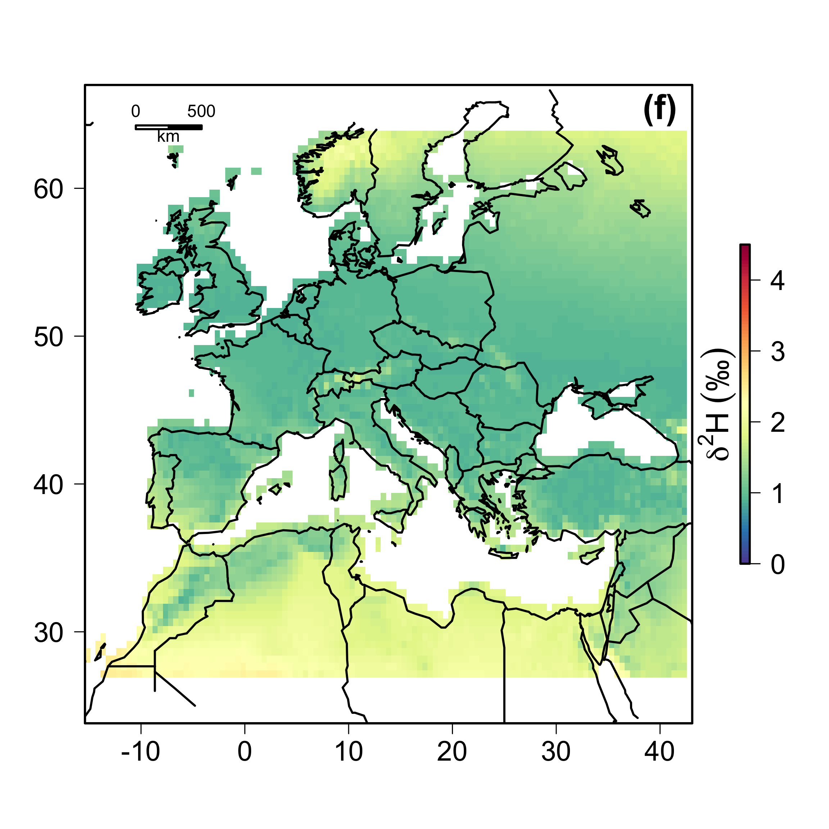

**Fig. S4.** Values of *rescale* across North America and Europe representing short- (a, c, d, e) and long-term (b, f) time periods. (a) 1996 mean = 1.00‰, (b) 1960-2000 mean = 0.91‰, (c) 2004 mean = 1.44‰, (d) 2005 mean = 1.44‰, (e) 2006 mean = 1.45‰, (f) 1960-2006 mean = 1.31‰.

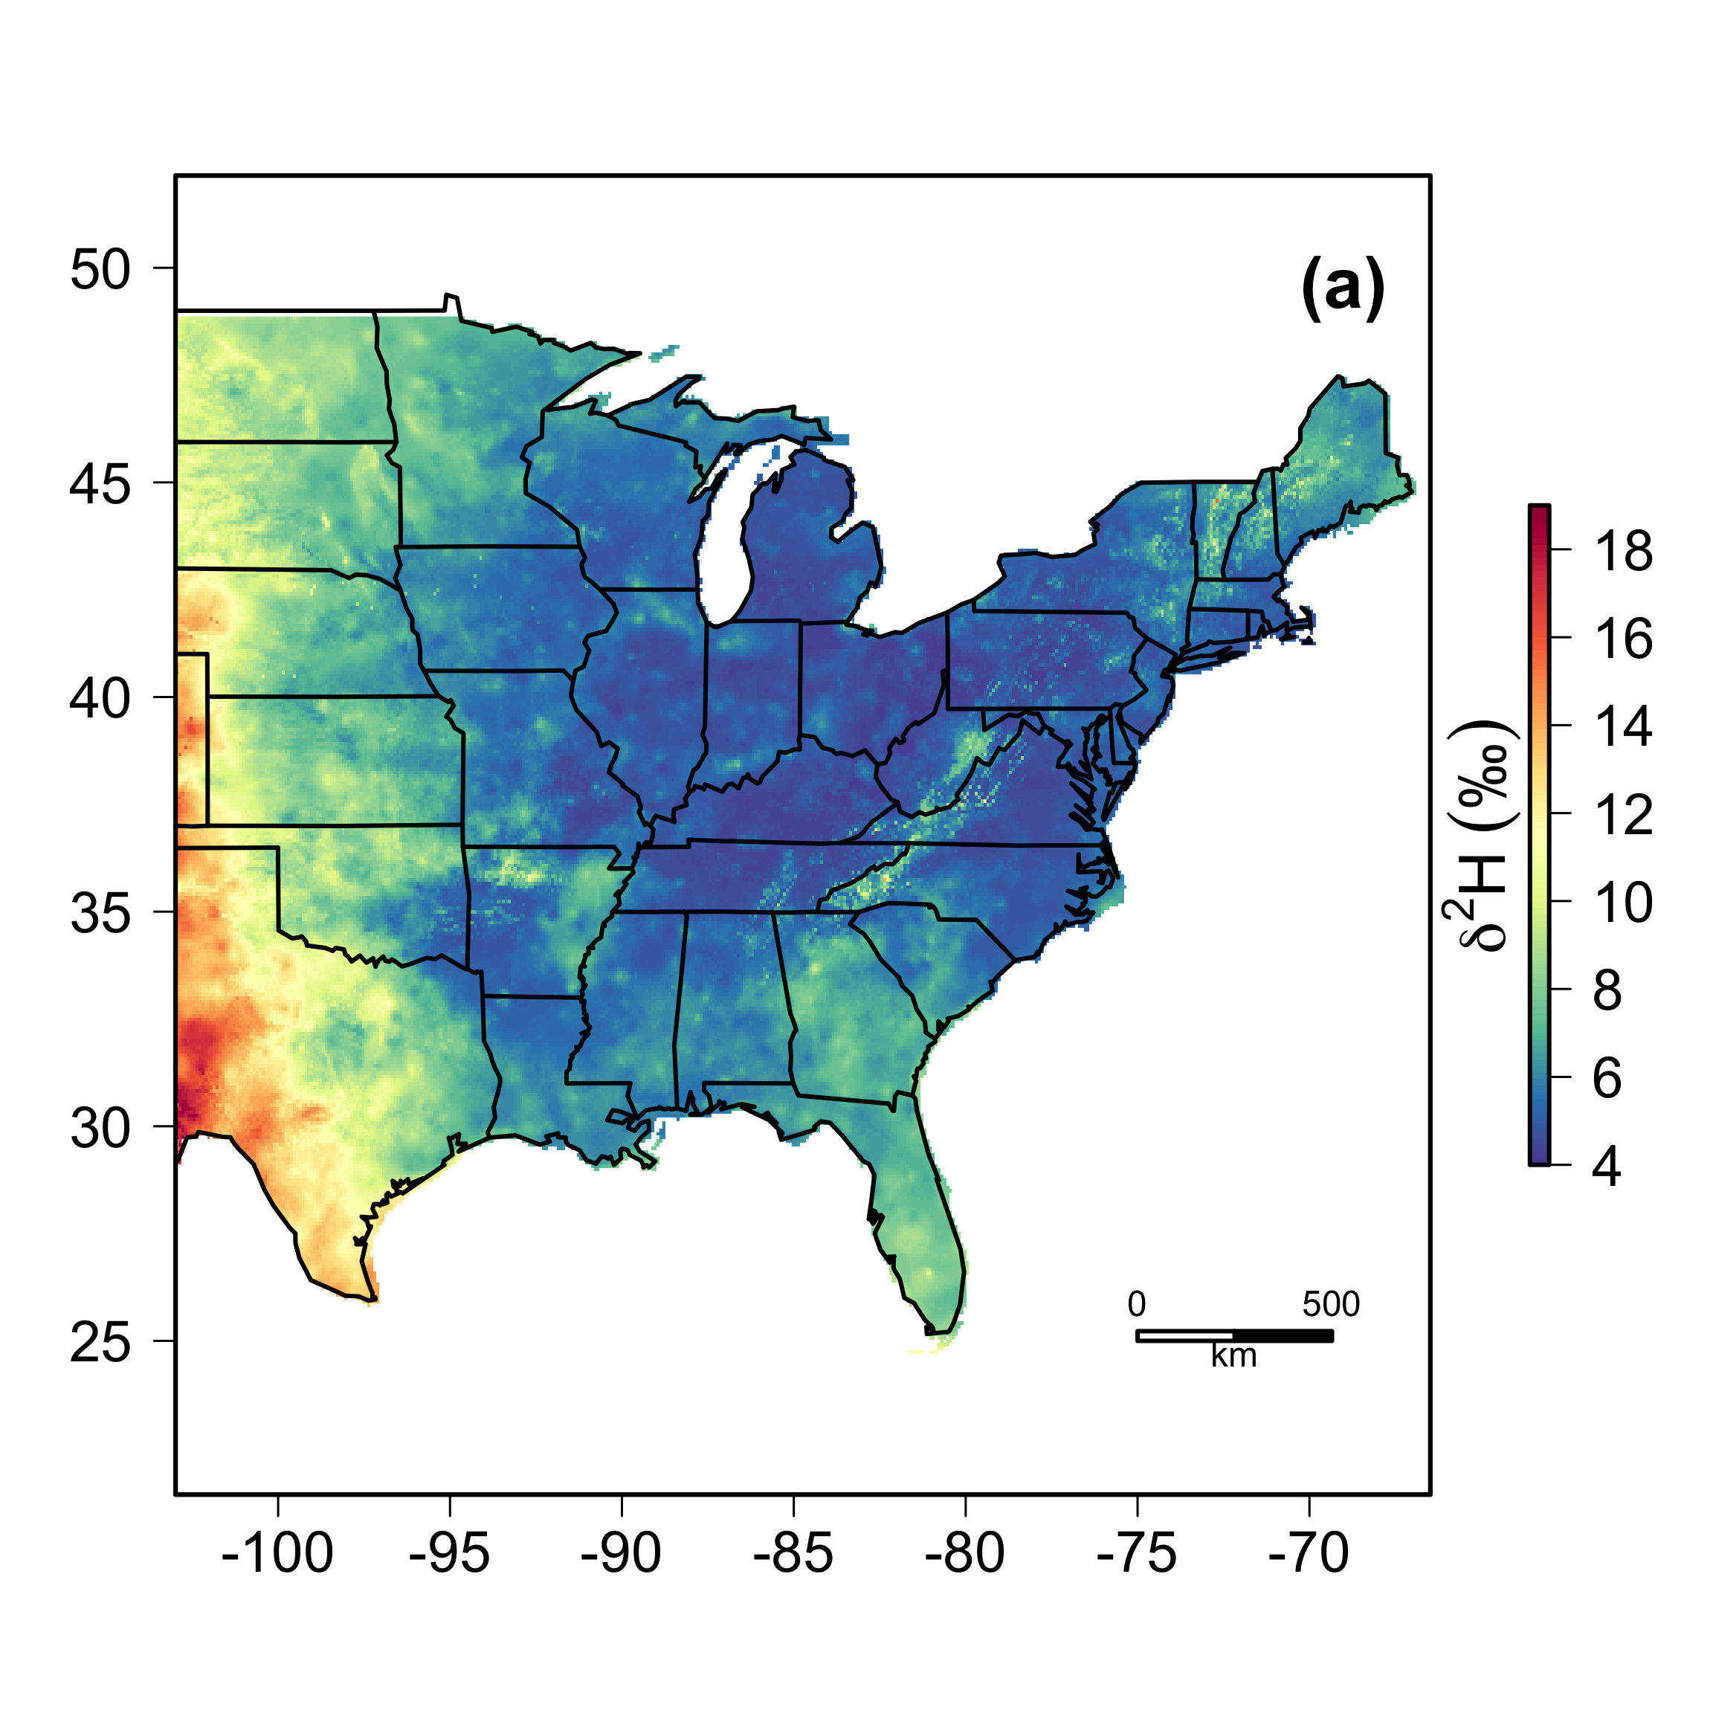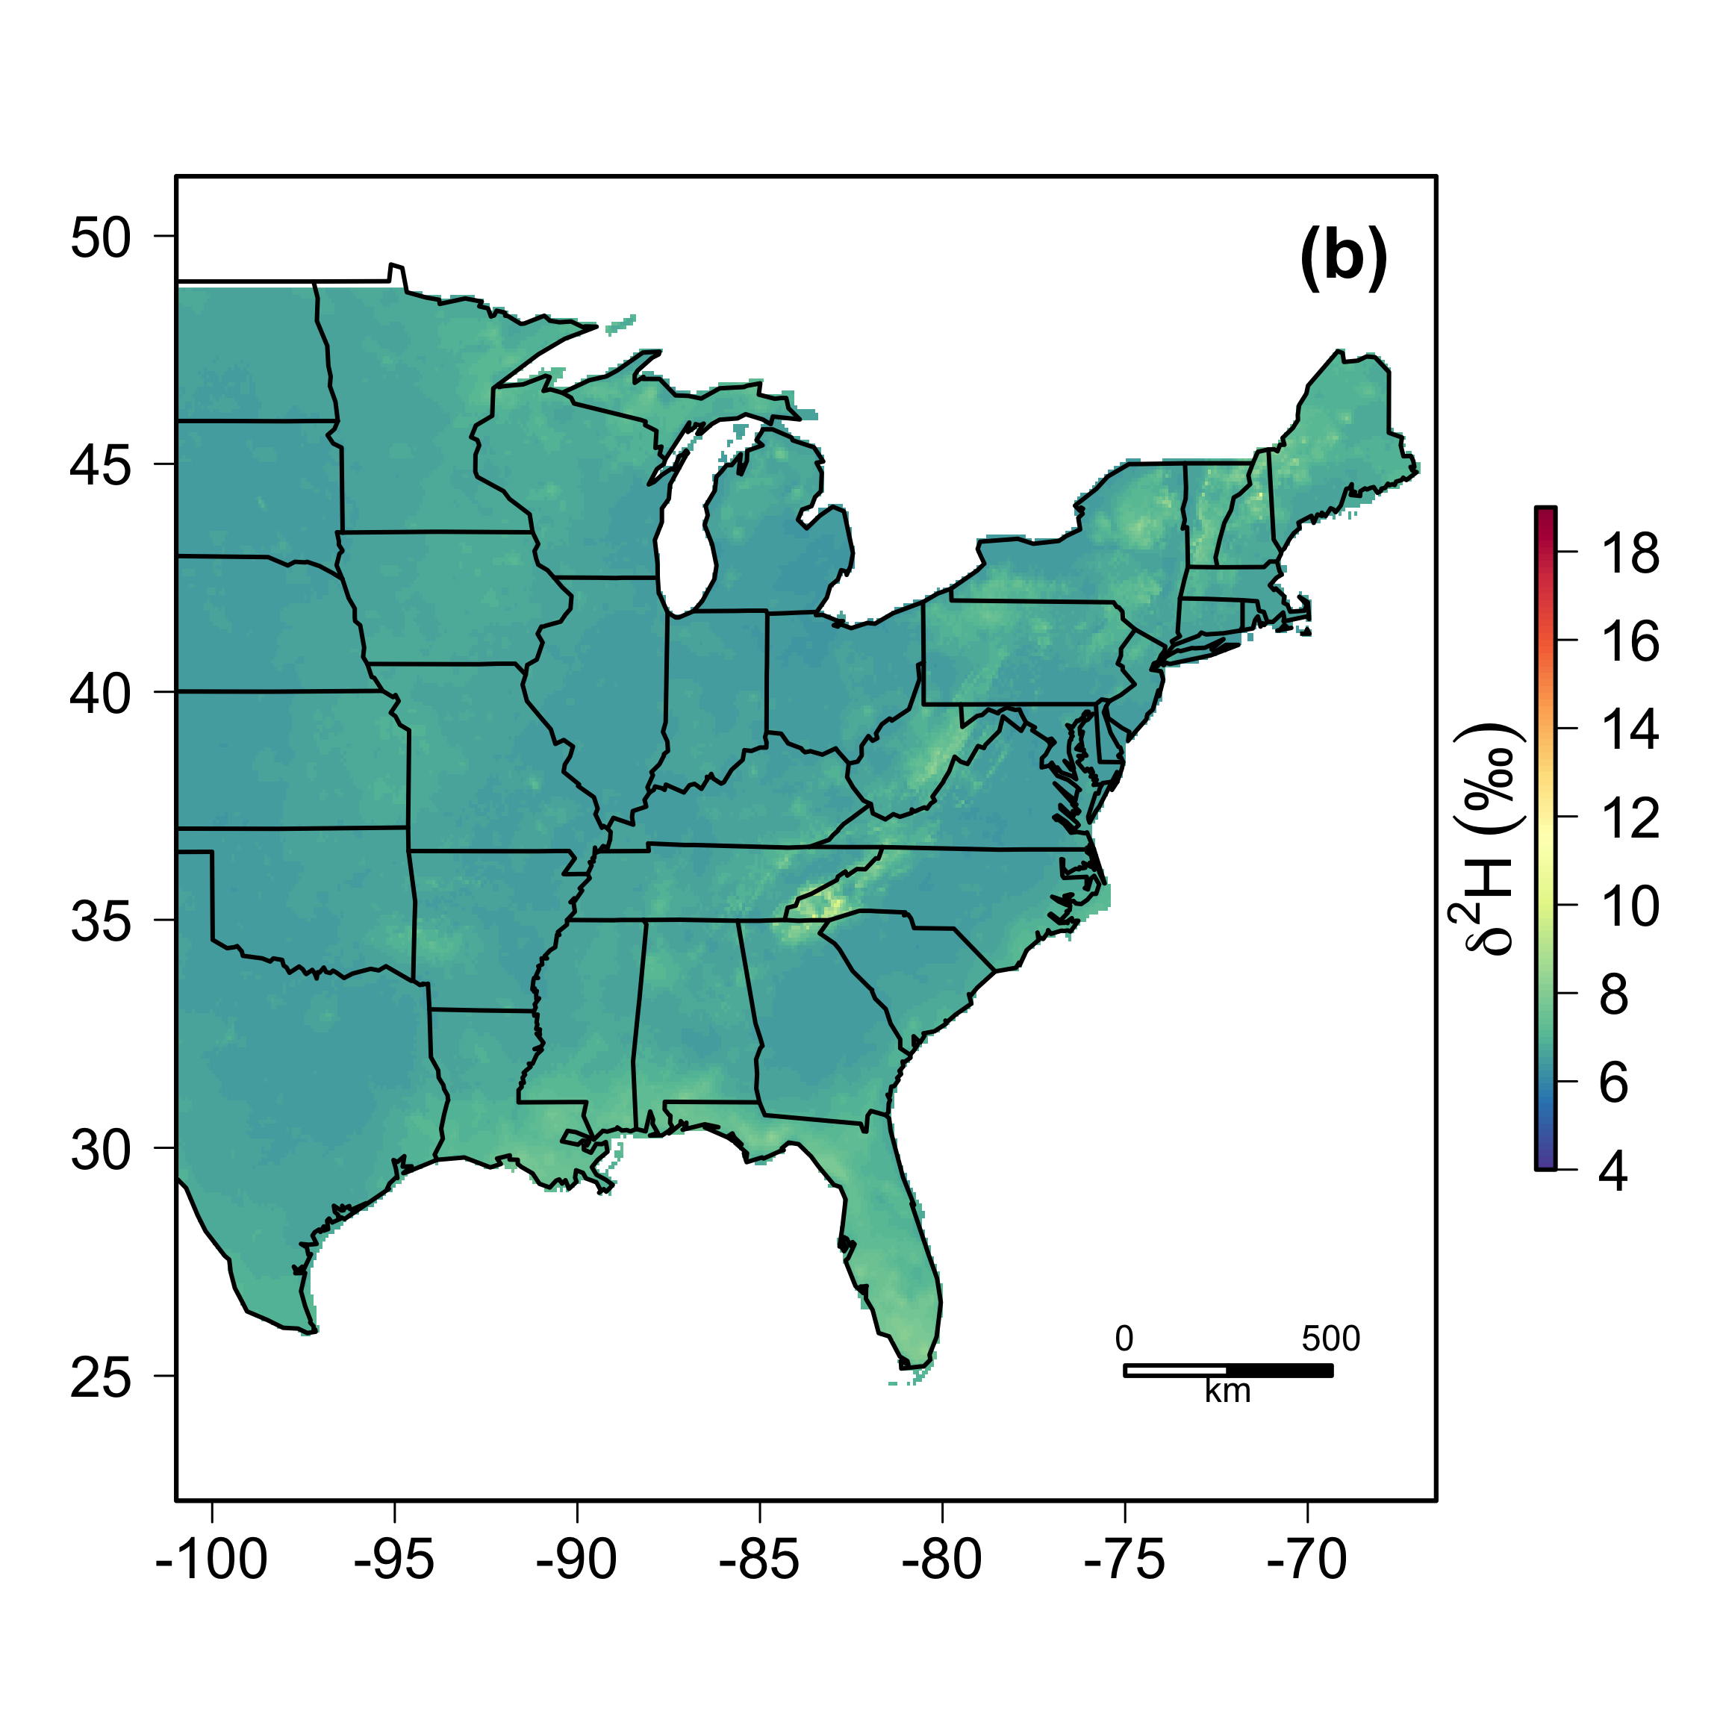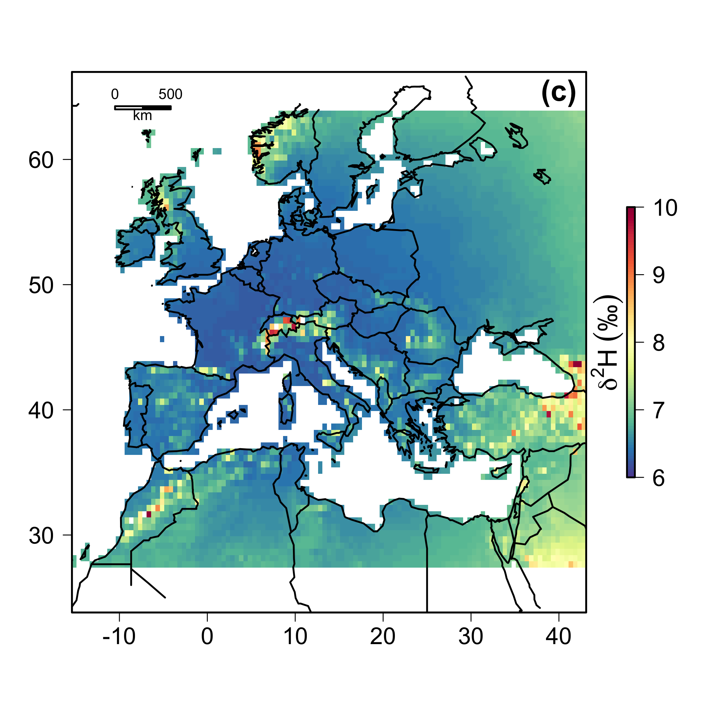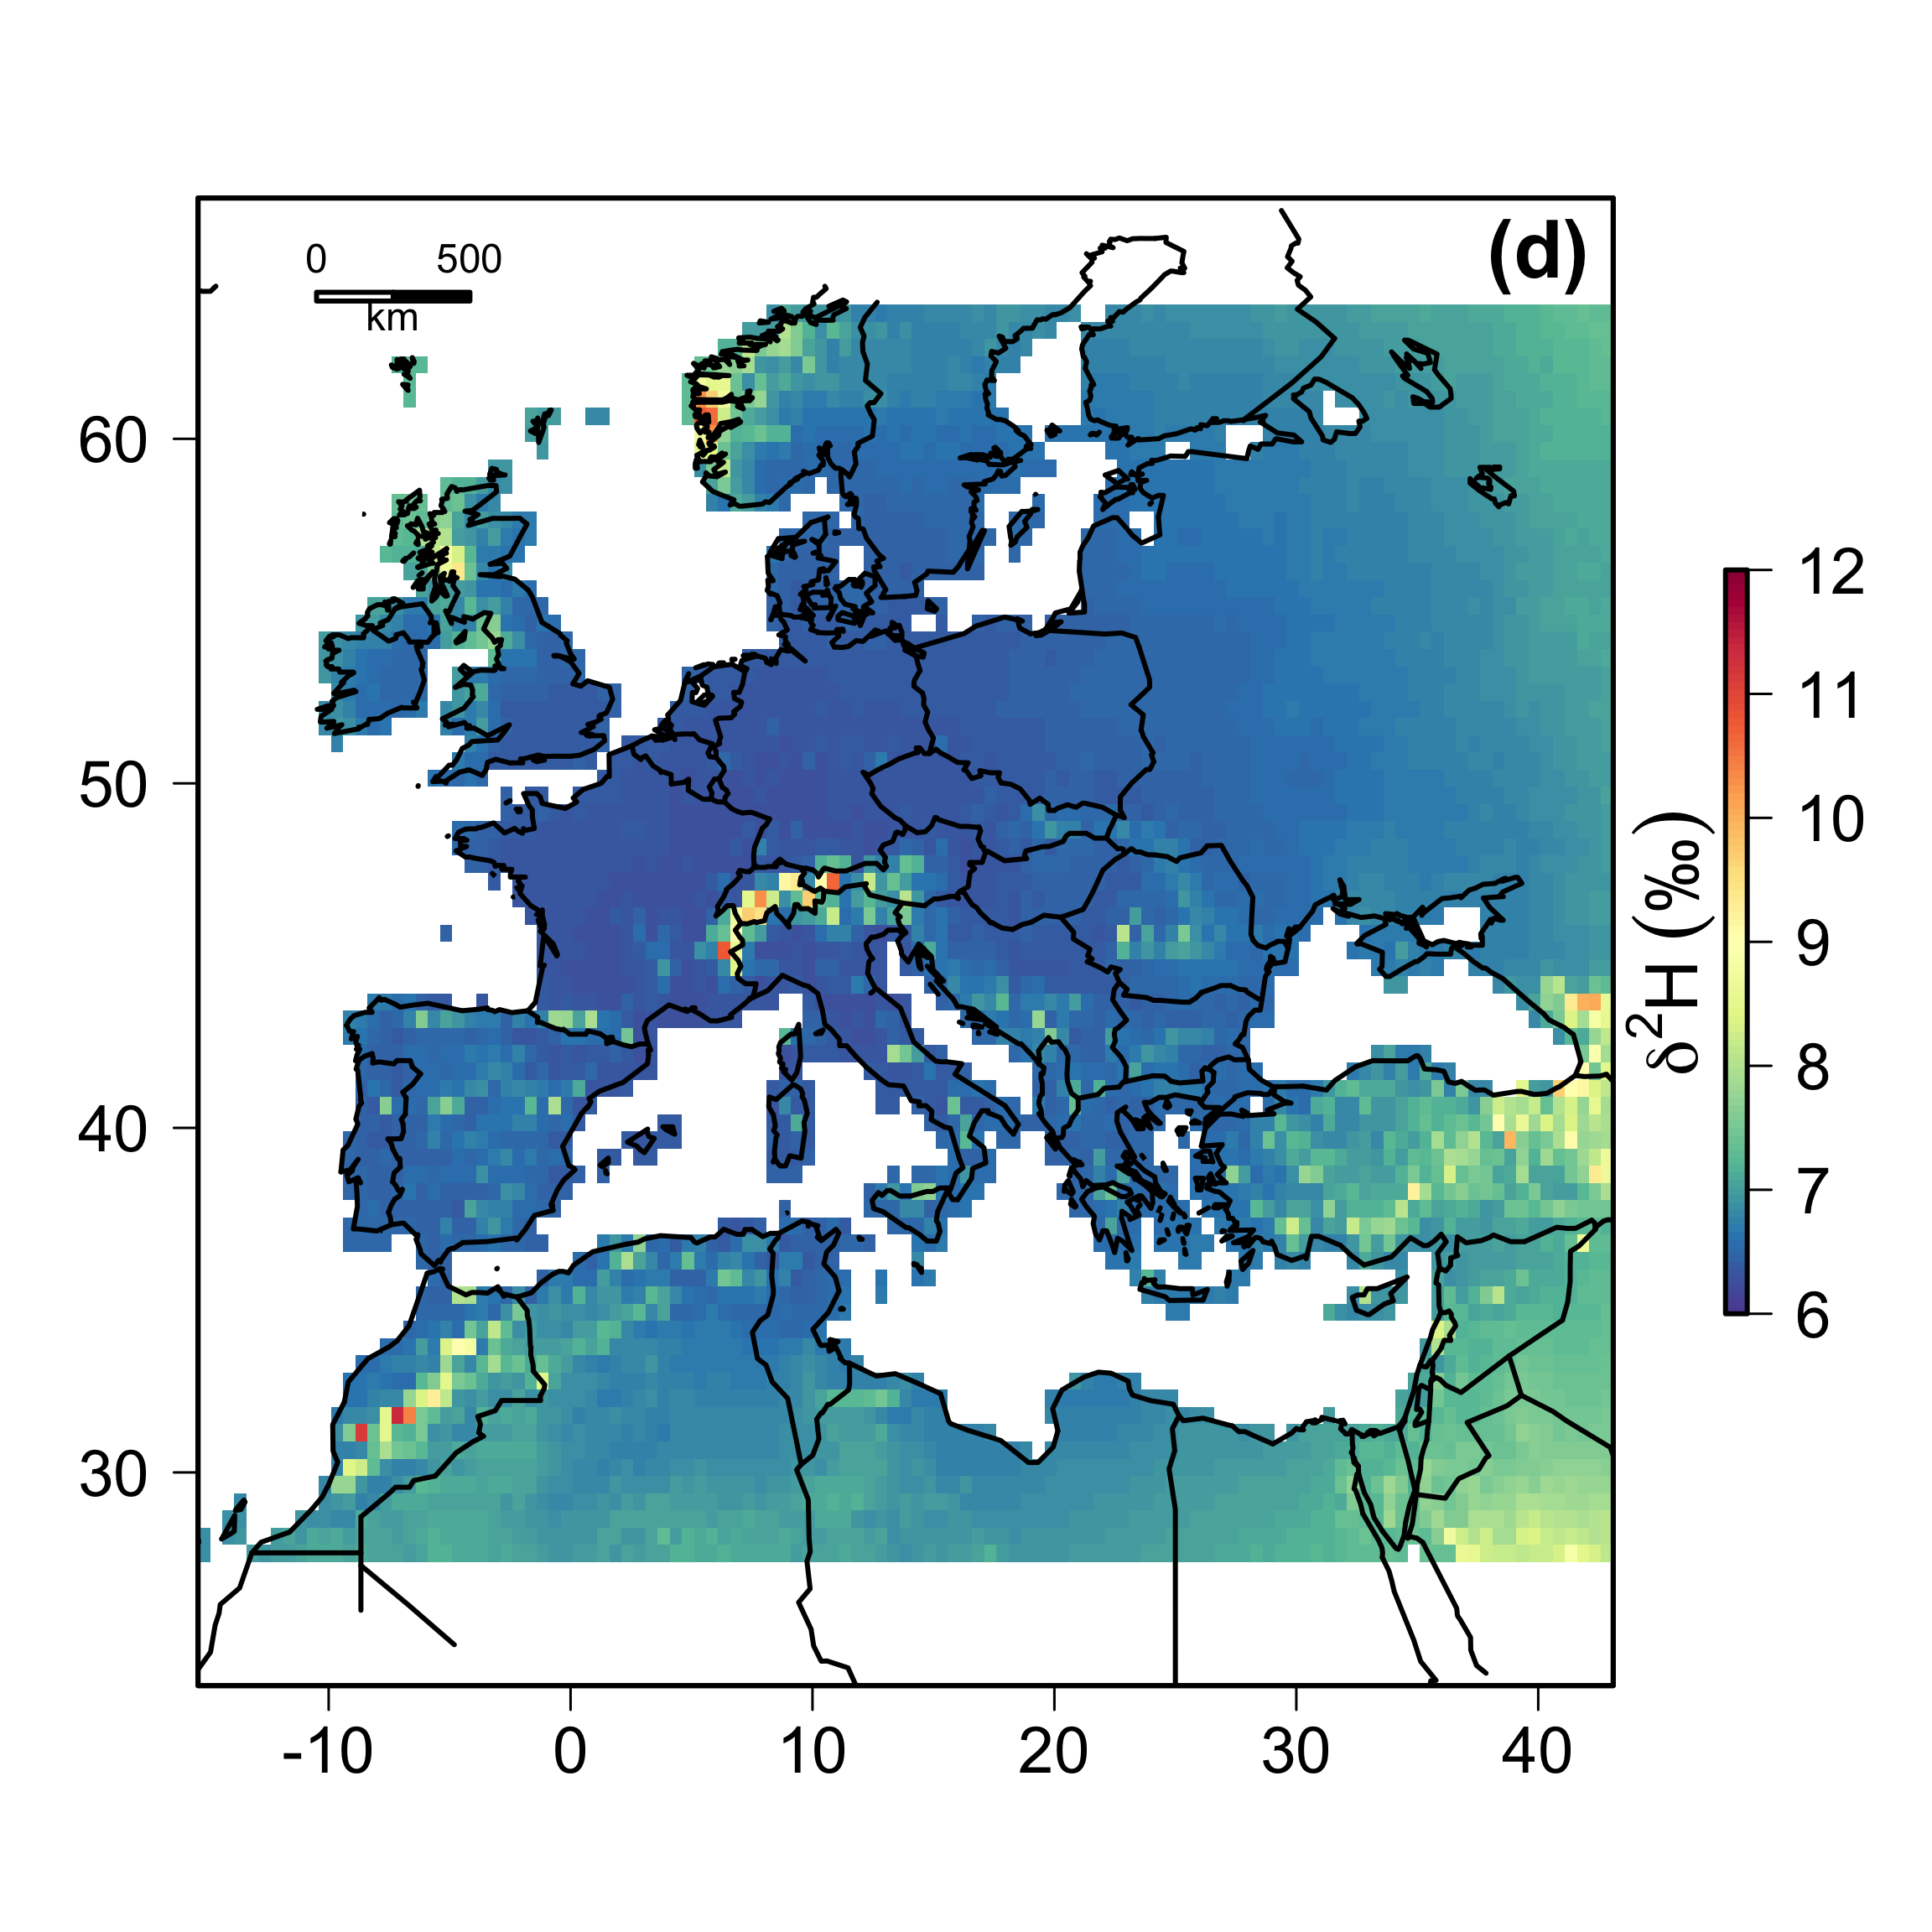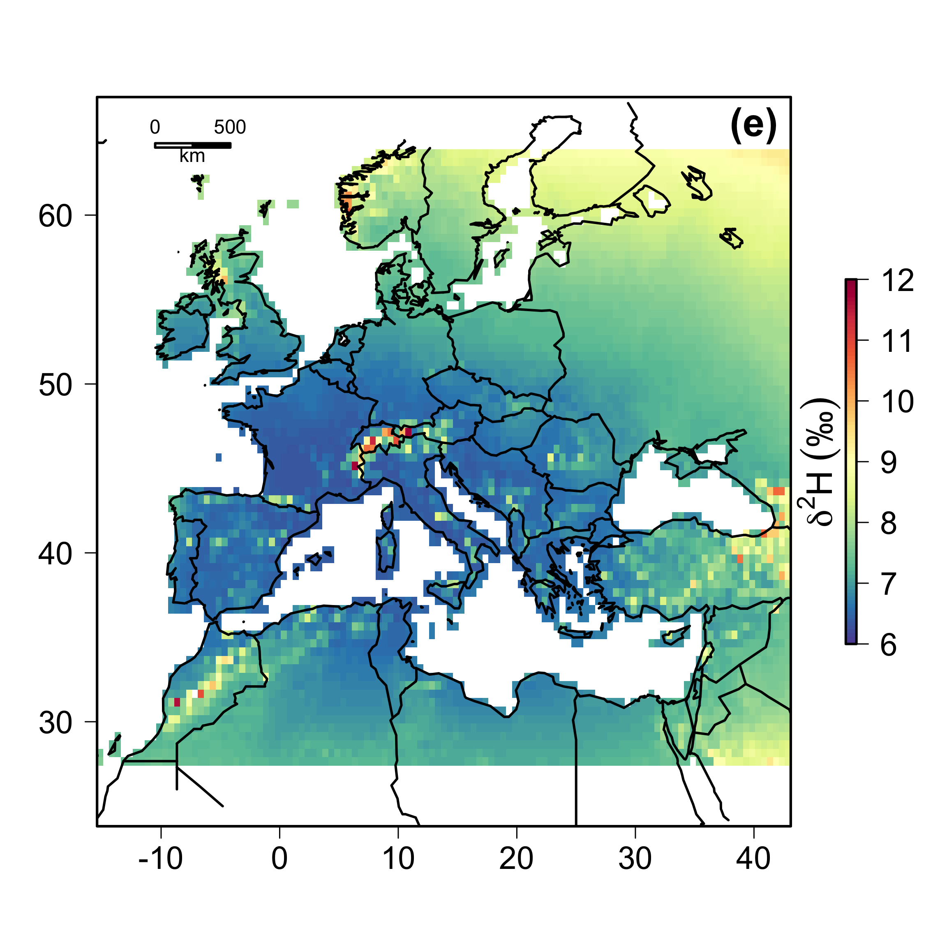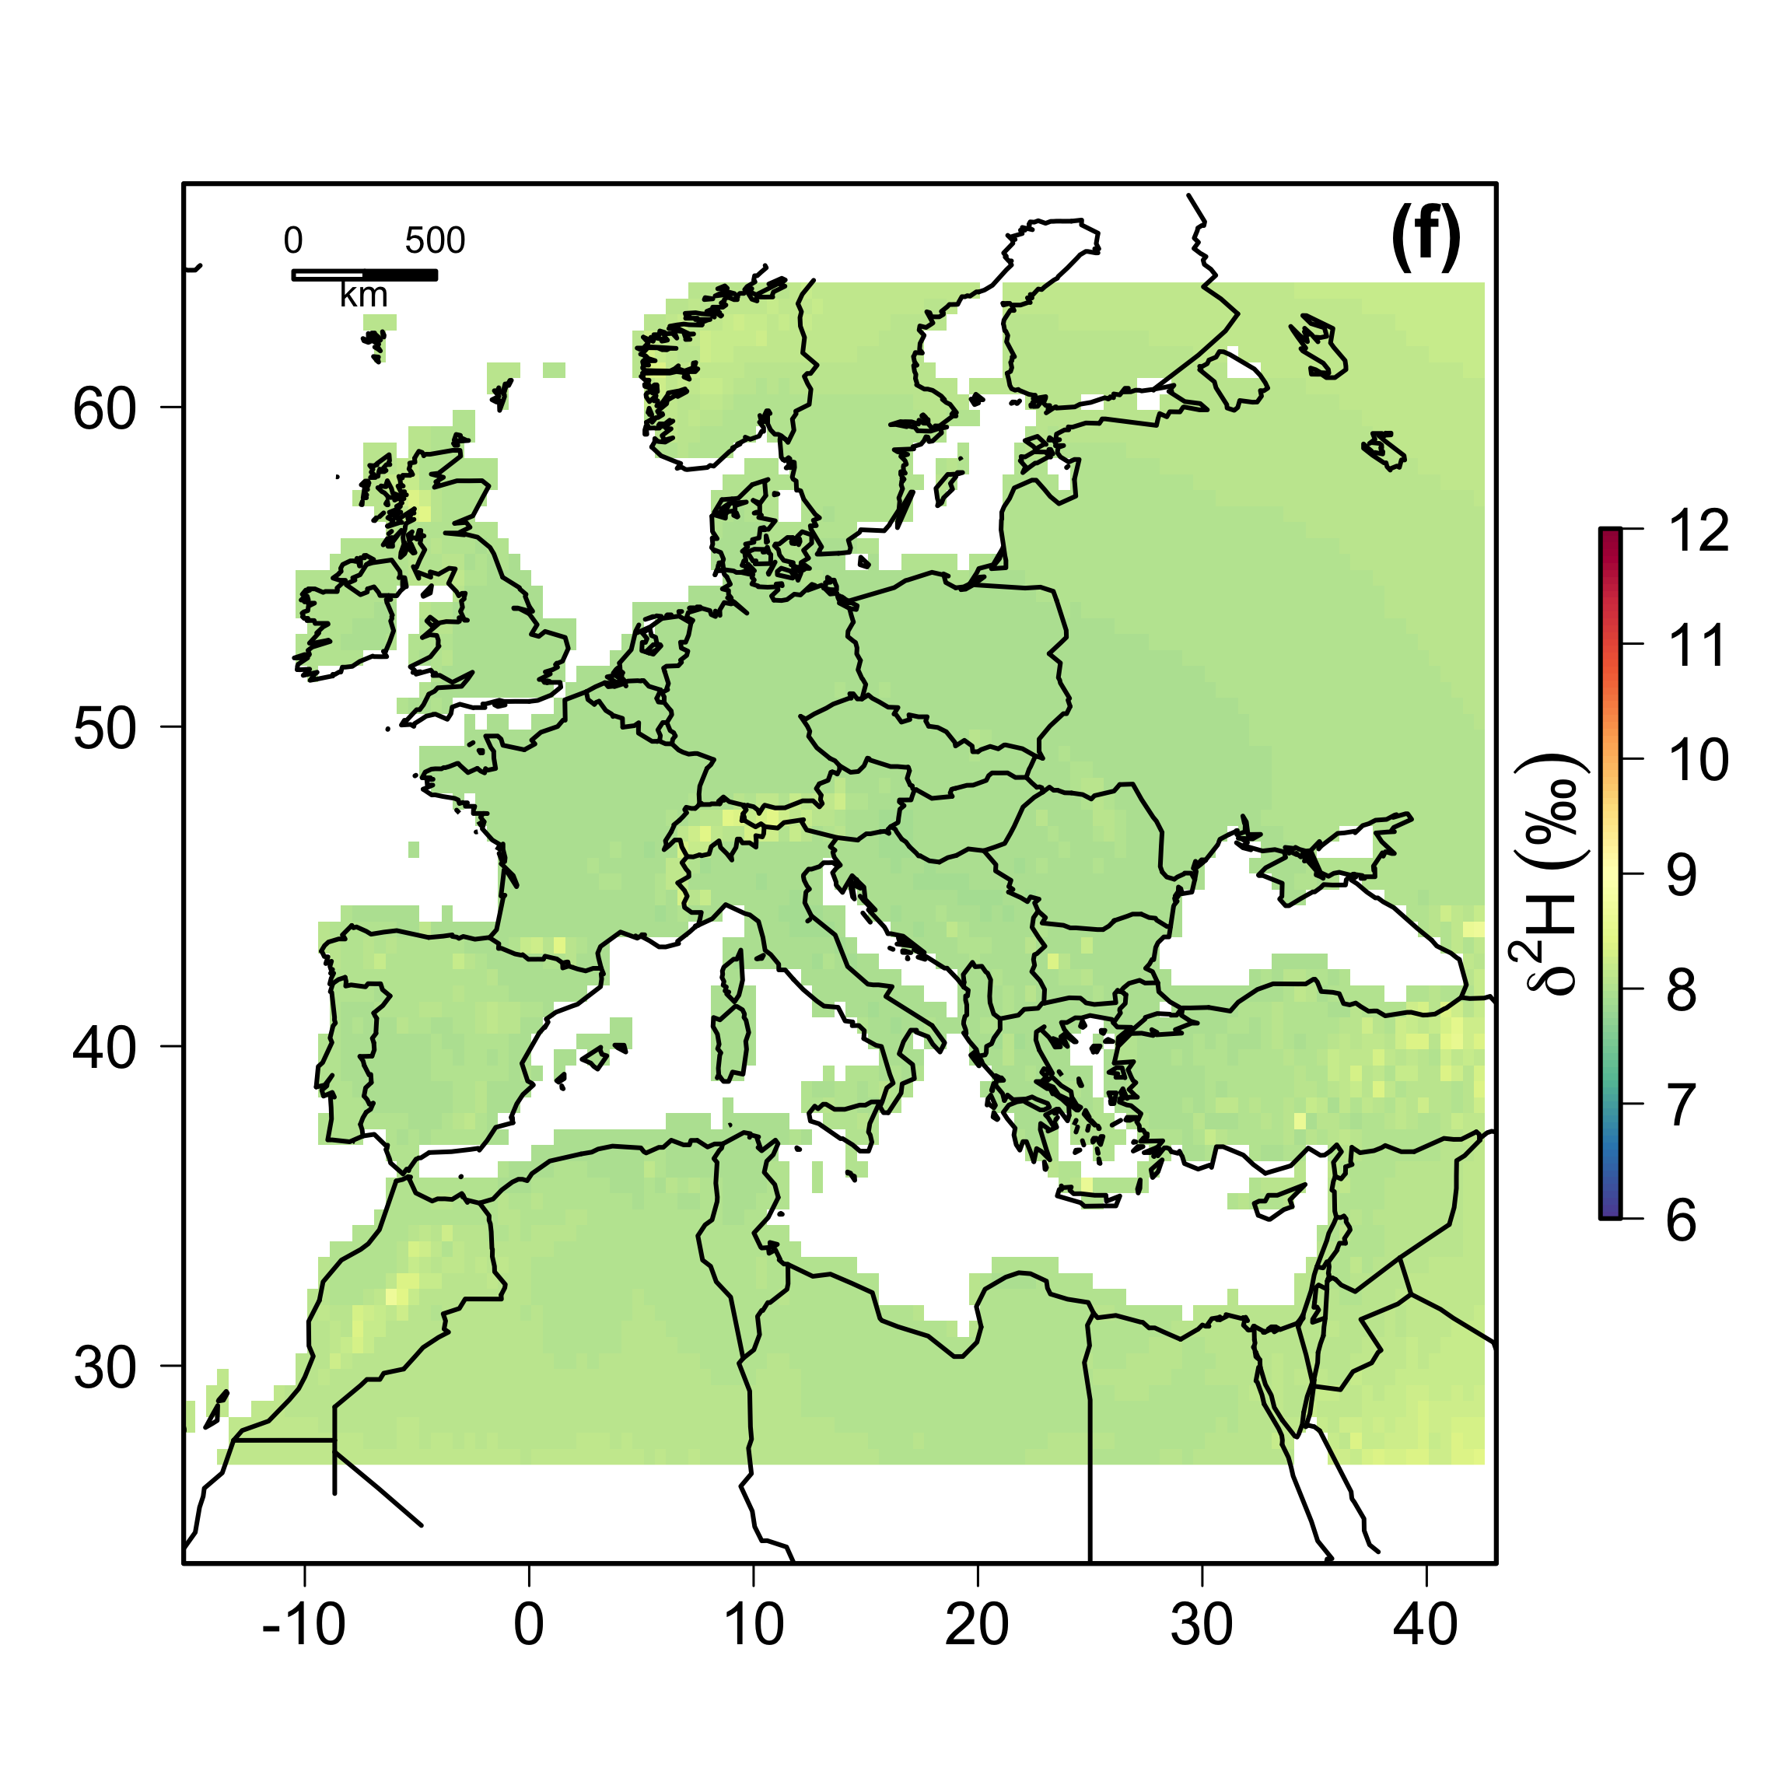

**Fig. S5.** Values of *precip* across North America and Europe representing short- (a, c, d, e) and long-term (b, f) time periods. (a) 1996 mean = 7.32‰, (b) 1960-2000 mean = 6.65‰, (c) 2004 mean = 6.77‰, (d) 2005 mean = 6.78‰, (e) 2006 mean = 7.26‰, (e) 1960-2006 mean = 8.01‰. The scales are the same for (a, b) and for (c-e). Note the wide range in uncertainty in the short-term isoscapes compared to the long-term isoscapes.

**Literature cited**

Bowen, G.J. (2010). Statistical and geostatistical mapping of precipitation water isotope ratios. *Isoscapes: understanding movement, pattern, and process on earth through isotope mapping* (eds J.B. West, G.J. Bowen & T.E. Dawson), pp. 139–160. Springer, Netherlands.

Bowen, G.J., Liu, Z., Vander Zanden, H.B., Zhao, L. & Takahashi, G. (2014). Geographic assignment with stable isotopes in IsoMAP. *Methods in Ecology and Evolution*, **5**, 201-206.

Bowen, G.J., West, J.B., Zhao, L., Takahashi, G., Miller, C. & Zhang, T. (2012). Cyberinfrastructure for isotope analysis and modeling. *Eos, Transactions American Geophysical Union*, **93**, 185–187.

Bowen, G.J. & Wilkinson, B. (2002). Spatial distribution of δ18O in meteoric precipitation. *Geology*, **30**, 315–318.

Dansgaard, W. (1964). Stable isotopes in precipitation. *Tellus*, **16**, 436–468.

Godsoe, W. (2014). Inferring the similarity of species distributions using Species’ Distribution Models. *Ecography*, **37**, 130–136.

Hobson, K.A., Wassenaar, L.I. & Taylor, O.R. (1999). Stable isotopes (δD and δ13C) are geographic indicators of natal origins of monarch butterflies in eastern North America. *Oecologia*, **120**, 397–404.

IAEA/WMO. (2011). Global Network of Isotopes in Precipitation. *The GNIP Database*. Retrieved from www.iaea.org/water

Mitchell, T.D. & Jones, P.D. (2005). An improved method of constructing a database of monthly climate observations and associated high-resolution grids. *International Journal of Climatology*, **25**, 693–712.

PRISM Climate Group. (2010).*Gridded climate data for the contiguous USA*. Retrieved from htpp://prisim.oregonstate.edu

Procházka, P., Van Wilgenburg, S.L., Neto, J.M., Yosef, R. & Hobson, K.A. (2013). Using stable hydrogen isotopes (δ2H) and ring recoveries to trace natal origins in a Eurasian passerine with a migratory divide. *Journal of Avian Biology*, **44**, 541–550.

Rozanski, K., Araguás-Araguás, L. & Gonfiantini, R. (1993). Isotopic patterns in modern global precipitation. *Geophysical Monograph Series* (eds P.K. Swart, K.C. Lohmann, J. McKenzie & S. Savin), pp. 1–36. American Geophysical Union, Washington, D. C.

U.S. National Geophysical Data Center. (1998). U.S. National Geophysical Data Center.

Wunder, M.B. (2010). Using isoscapes to model probability surfaces for determining geographic origins. *Isoscapes: Understanding Movement, Pattern, and Process on Earth Through Isotope Mapping* (eds J.B. West, G.J. Bowen, T.E. Dawson & K.P. Tu), pp. 251–270. Springer Netherlands.

Wunder, M.B., Jehl, J.R. & Stricker, C.A. (2012). The early bird gets the shrimp: confronting assumptions of isotopic equilibrium and homogeneity in a wild bird population. *Journal of Animal Ecology*, **81**, 1223–1232.

Wunder, M.B. & Norris, D.R. (2008). Improved estimates of certainty in stable-isotope-based methods for tracking migratory animals. *Ecological Applications*, **18**, 549–559.